|  |  |  |  |  |  |
| --- | --- | --- | --- | --- | --- |
| Subject Name: **Source Code Management**  Subject Code: **22CS003**  Session: **2022-23**  Department: **DCSE**  logo   |  |  |  | | --- | --- | --- | | **Submitted By:**  Kajal  2210990469-First Year  G24-B  **Submission of:-**  Task 1.1 & 1.2 |  | **Submitted To:**  Dr. Chetna Kaushal | |  |  |
|  |  |  |

**List of Programs**

|  |  |  |
| --- | --- | --- |
| **S. No** | **Program Title** | **Page No.** |
| 1 | Setting up of Git Client | 3 |
| 2 | Setting up GitHub Account | 5 |
| 3 | Generate logs | 8 |
| 4 | Create and visualize branches | 9-10 |
| 5 | Git life cycle description | 11-12 |
| 6 | Add collaborators on GitHub Repo | 13-16 |
| 7 | Fork and Commit | 17-18 |
| 8 | Merge and Resolve conflicts created due to own activity and collaborators activity. | 19-21 |
| 9 | Reset and revert | 21-24 |

|  |  |  |
| --- | --- | --- |
|  |  |  |

Experiment 1

**Aim:** Setting up of Git Client

**Theory: Setting up of Git Client**

GIT: It’s a Version Control System (VCS). It is a software or we can say a server by which we are able to track all the previous changes in the code. It is basically used for pushing and pulling of code. We can use git and git-hub parallelly to work with multiple members or individually. We can make, edit, recreate, copy or download any code on git hub using git.

**Procedure:** We can install Git on Windows, using the most official build which on any search engine. We can go on <https://git-scm.com/download/win>and can select the platform and bit-version to download. And after clicking on your desired bit-version or ios it will start downloading automatically.

Git is a free and open-source version control system used to handle small to very large projects efficiently. This is also used for tracking changes in any set of files and usually helps in coordinating work among members of a team. Hence, enables multiple developers to work together on non-linear development.

History of VCS : The very first Version Control System was created in 1972 at Bell Labs where they also developed UNIX. The first one was called SCCS (Source Code Control System). It was available only for UNIX and only worked with Source Code files. Some types of Version Control Systems are:

• Local VCS: No internet is needed because it uses a database to keep and track of files.

• Centralized VCS: Centralized version control systems are based on the idea that there is a single “central” copy of your project somewhere (probably on a server), and programmers will “commit” their changes to this central copy. This simply means recording the change in the central system (OS).

• Distributed VCS: A type of version control where the complete codebase including its full version history is mirrored on every developer's computer.

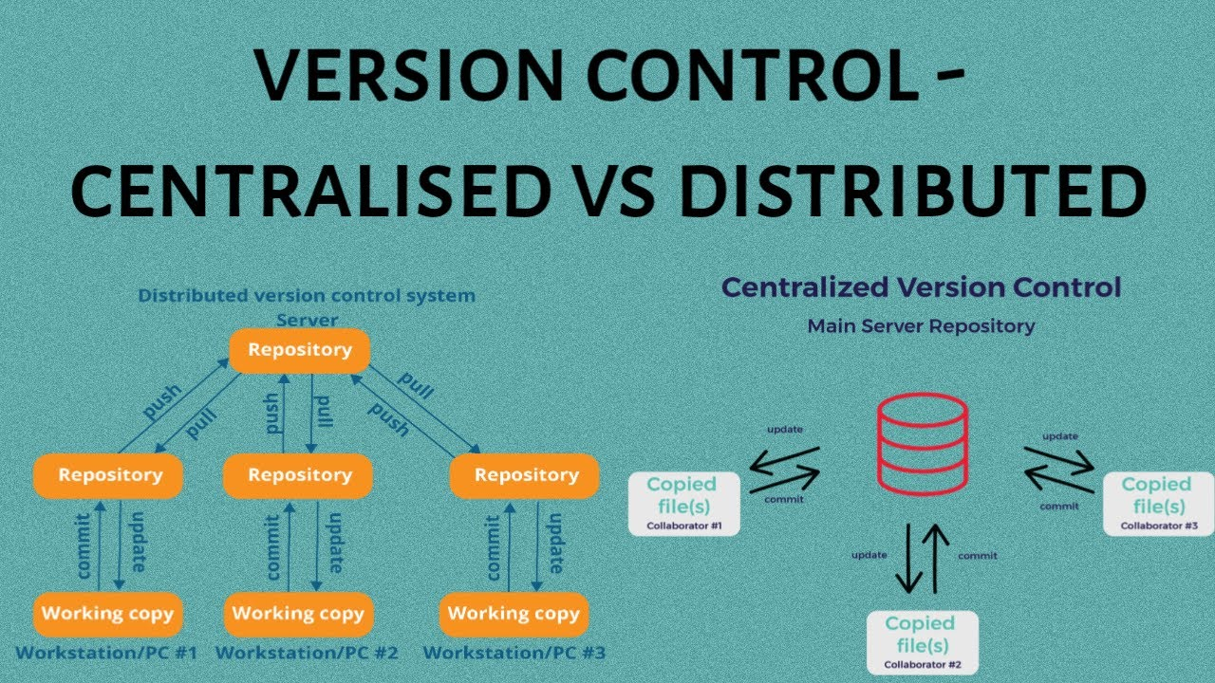

**Snapshots of download:**

1.Go to git-scm.com and go to downloads section.

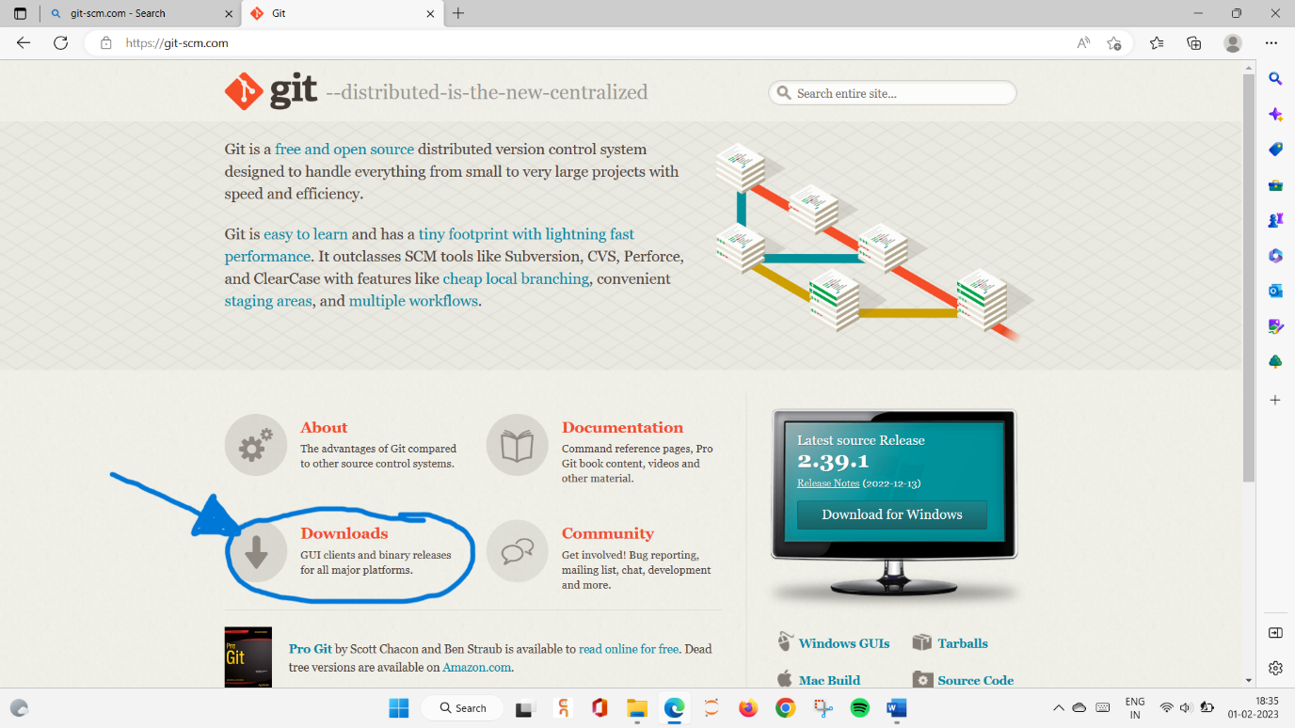

2. In downloads section go to download for windows

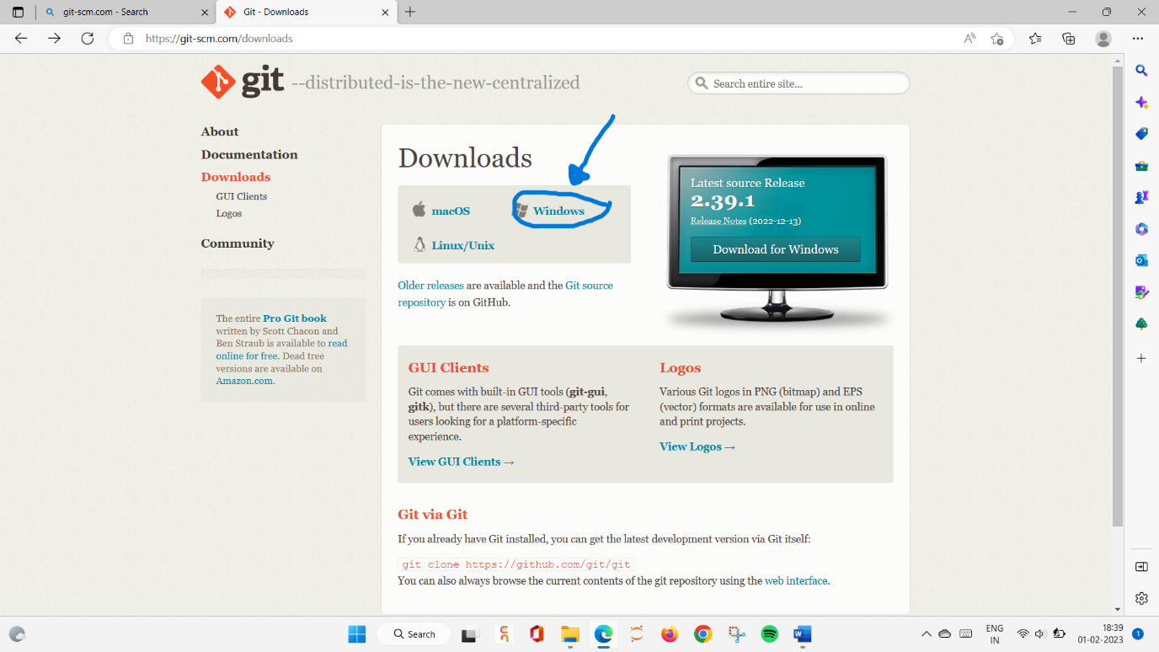

3.Next, click on “CLICK HERE TO DOWNLOAD” . After clicking on this ,an exe file will be downloaded.

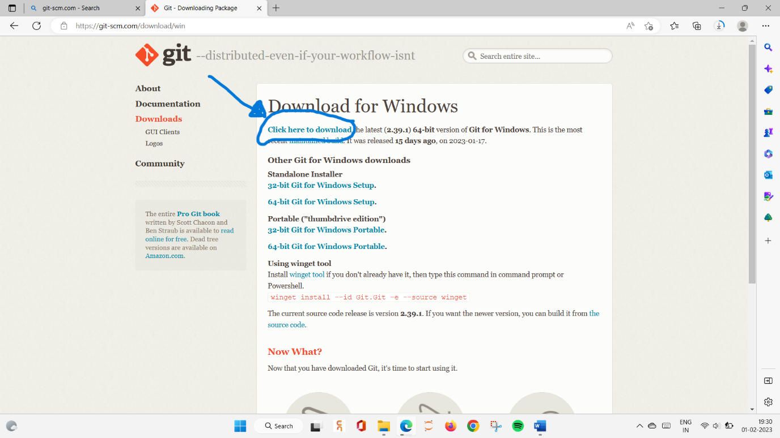

4.Open the downloaded exe file.A prompt will appear asking for permission

Give it the required permissions and the following window will appear showing the progress of installation.

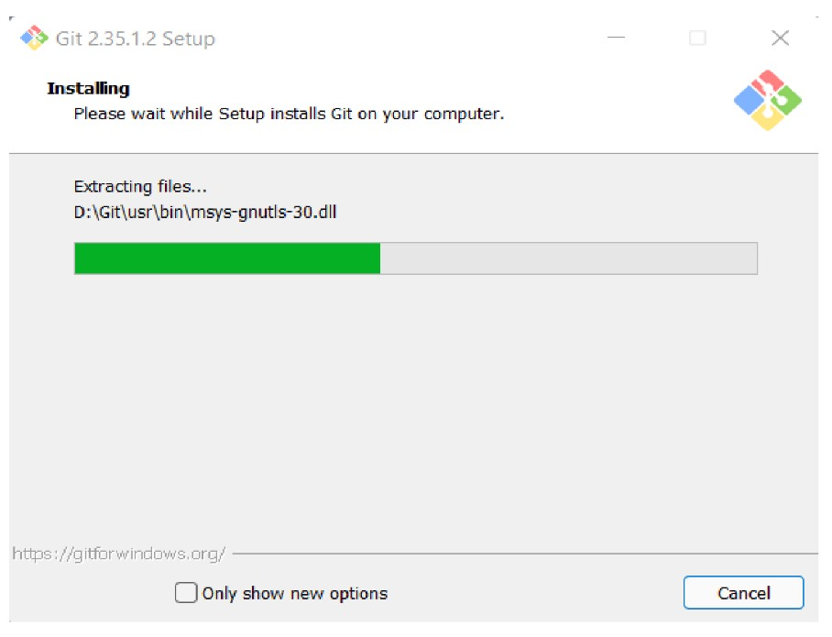

Git Installation

**5. Git bashed installed finally**

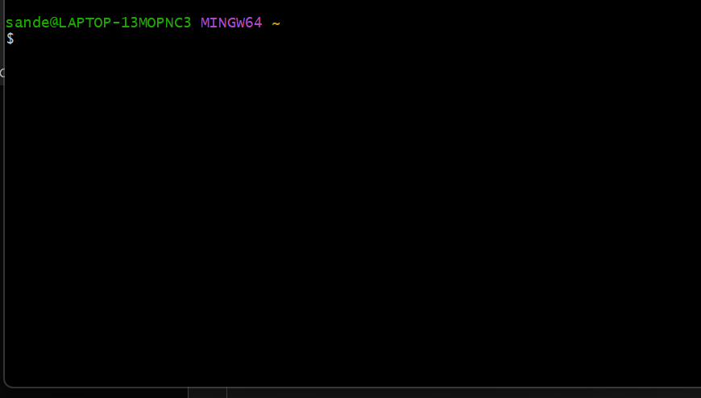

**Git Bash Launched**

# Experiment 2

**Theory:**

GitHub:GitHub is a website and cloud-based service (client) that helps an individual or developers to store and manage their code. We can also track as well as control changes to our or public code.

Advantages of GitHub: GitHub has a user-friendly interface and is easy to use. We can connect the git-hub and git but using some commands shown below in figure 001. Without GitHub we cannot use Git because it generally requires a host and if we are working for a project, we need to share it will our team members, which can only be done by making a repository. Additionally, anyone can sign up and host a public code repository for free, which makes GitHub especially popular with open-source projects.

**Procedure:**

To make an account on GitHub, we search for GitHub on our browser or visit [https://github.com/signup.](https://github.com/signup) Then, we will enter our mail ID and create a username and password for a GitHub account.

**1.**Search github.com on browser.

**Snapshots**

**–**

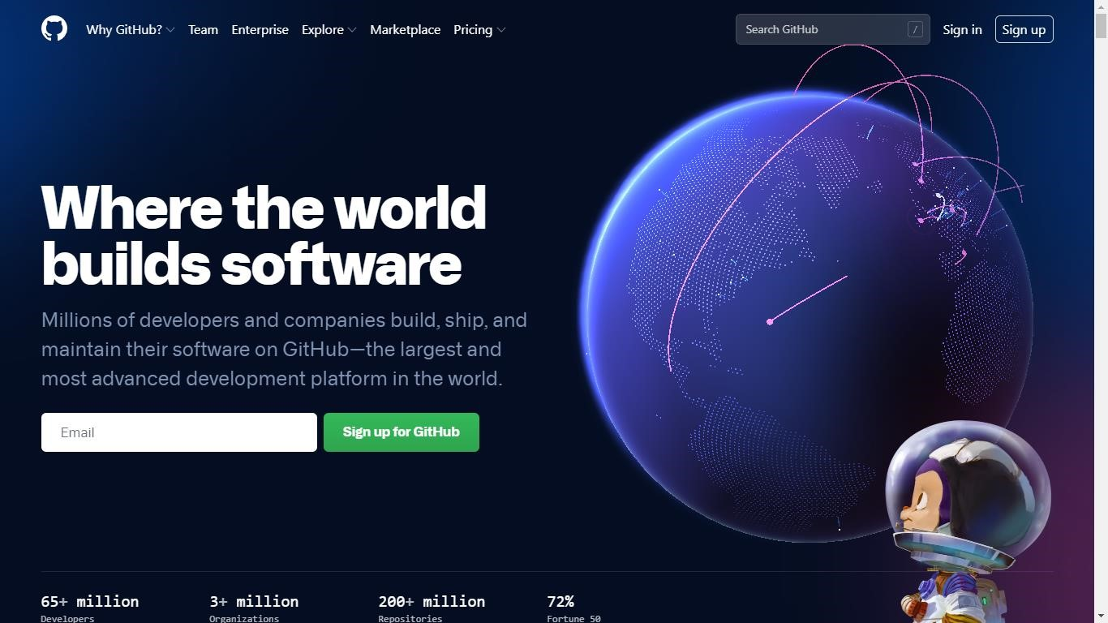

After visiting the link this type of interface will appear, if you already have an account, you can sign in and if not, you can create.

2.Who don’t have a git hub account , click on sign up and fill up all the details they ask for. After filling all the required details, account will be created .

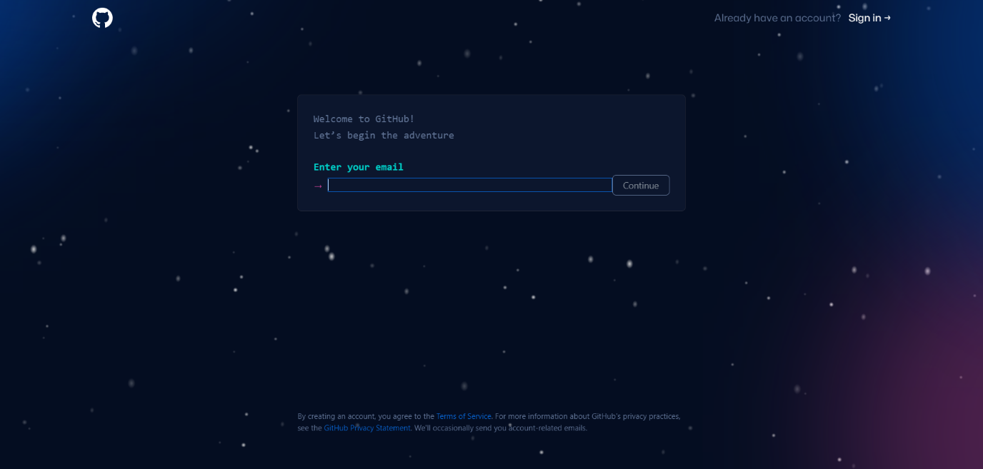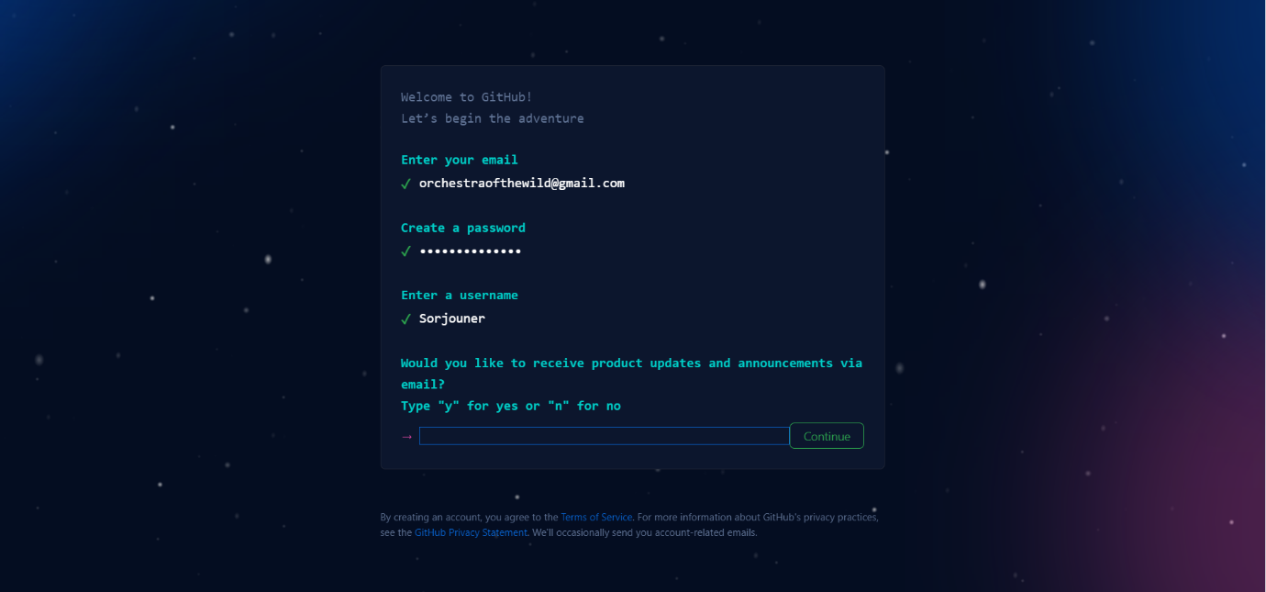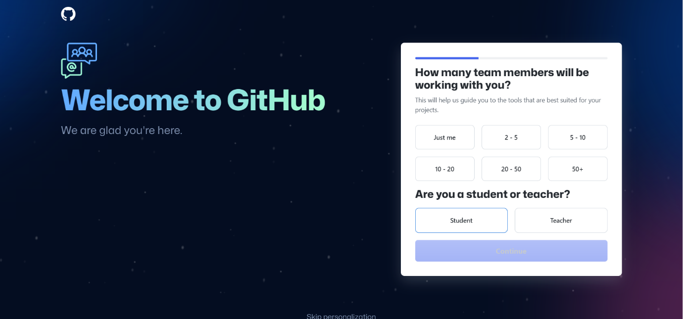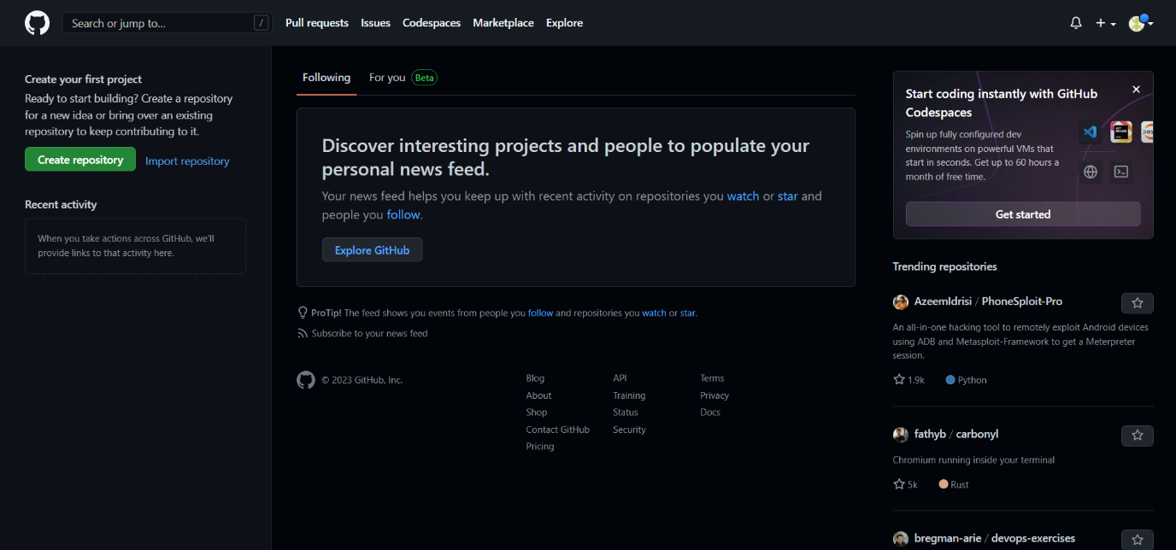

3.If you already have an account, then simply click on sign in

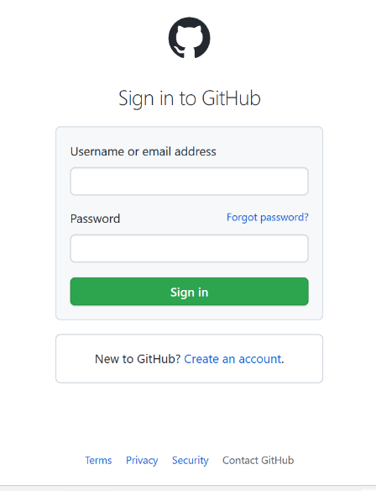

**Result:** We have successfully created out github account

# Experiment 3

**Aim:** Program to Generate log

**Theory:**

Logs: Logs are nothing but the history which we can see in git by using the code git log.

It contains all the past commits, insertions and deletions in it which we can see any time. Logs helps to check that what were the changes in the code or any other file and by whom. It also contains the number of insertions and deletions including at which time it was changed.

**Procedure:**

First of all, create a local repository using Git.

For this, you have to make a folder in your device. Open GITBASH and write this folder’s path

with command cd “path”.



To create a new local repository, use the command “git init”

and it creates a folder “.git”.

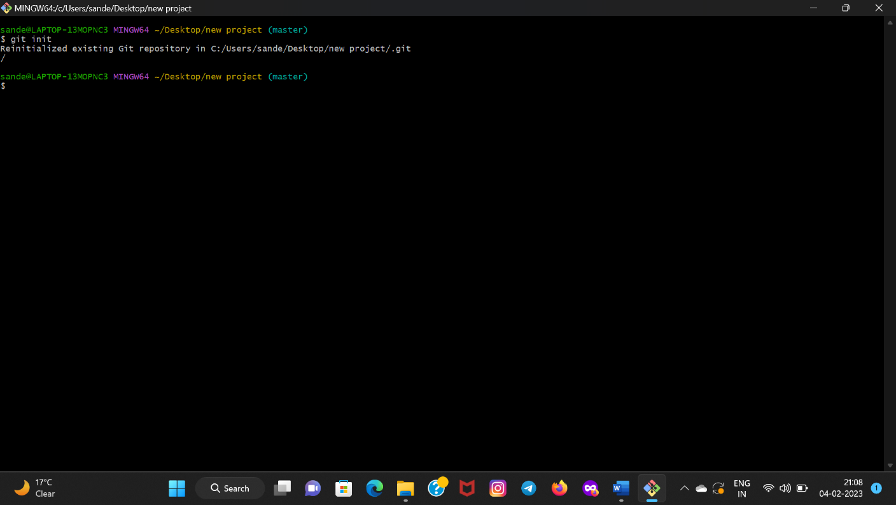

When we use GIT for the first time, we have to give the user name and email so that if I am going to change in project, it will be visible to all.

For this, we use command:

“git config --global user.name Name”

“git config --global user.email email”

For verifying the user’s name and email, we use:

“git config --global user.name”

“git config --global user.email”

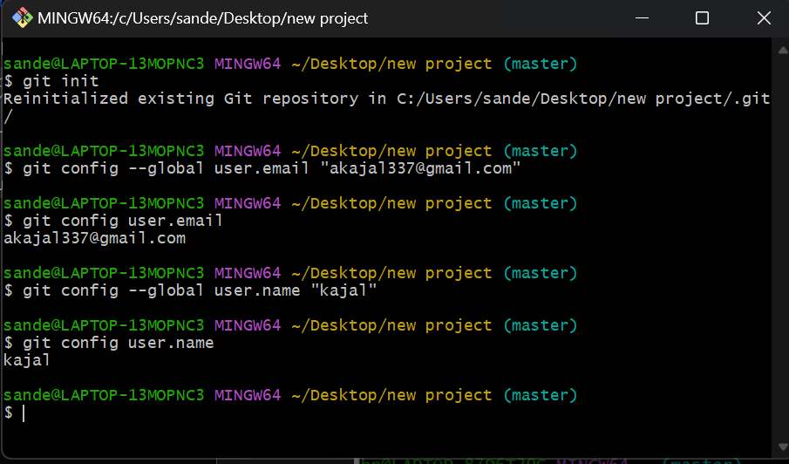

Now to check status of the repository we will write following command:

“git status”

then the following window will appear:

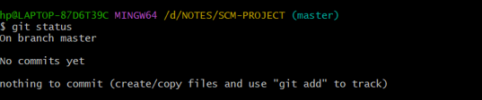

Now create a text document using command “touch text_document_name.txt”

To write inside this file we can write command “vi editor” 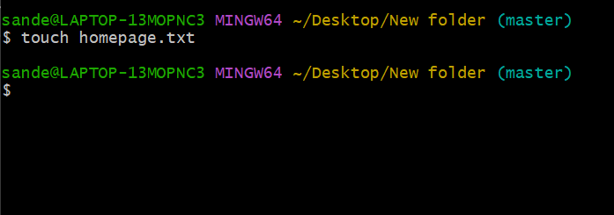

Then a window will appear and what we write here , can be Seen in that text file.

For going back to git bash we can simply use esc button and then press colon and write :wq and enter

To see what is written inside the file you can write command “cat text_document_name.txt”. If we check git status there will be one untracked file show in red colour. This file is in working directory for now To add this to staging area we can simply do by following command. After this when we will check git status then it will be added to staging area and will be shown in green colour . Now this file is in staging area, to add this in repository we will write following command

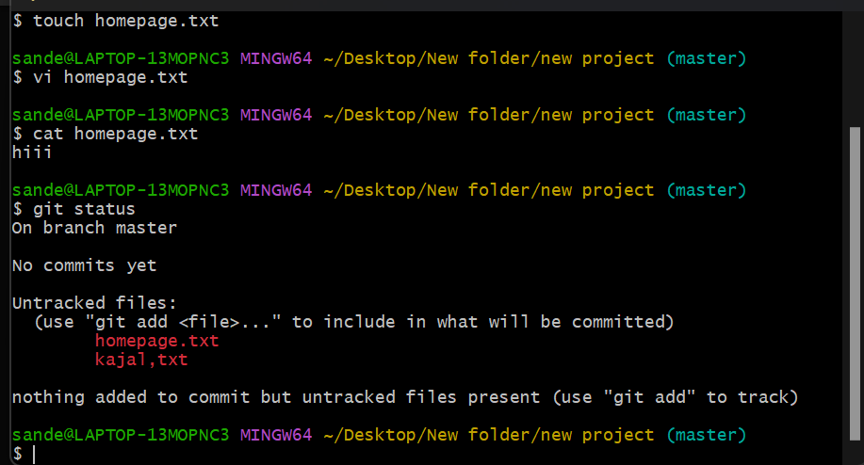

## 

When we have added this file in repository area, if we check status now, WORKING TREE

CLEAN will be written here. Then to check the editing s ,we write GIT LOG here logs will be seen who edited the file, when the file is edited .To check logs in one line we use the command GIT LOG –ONELINE.

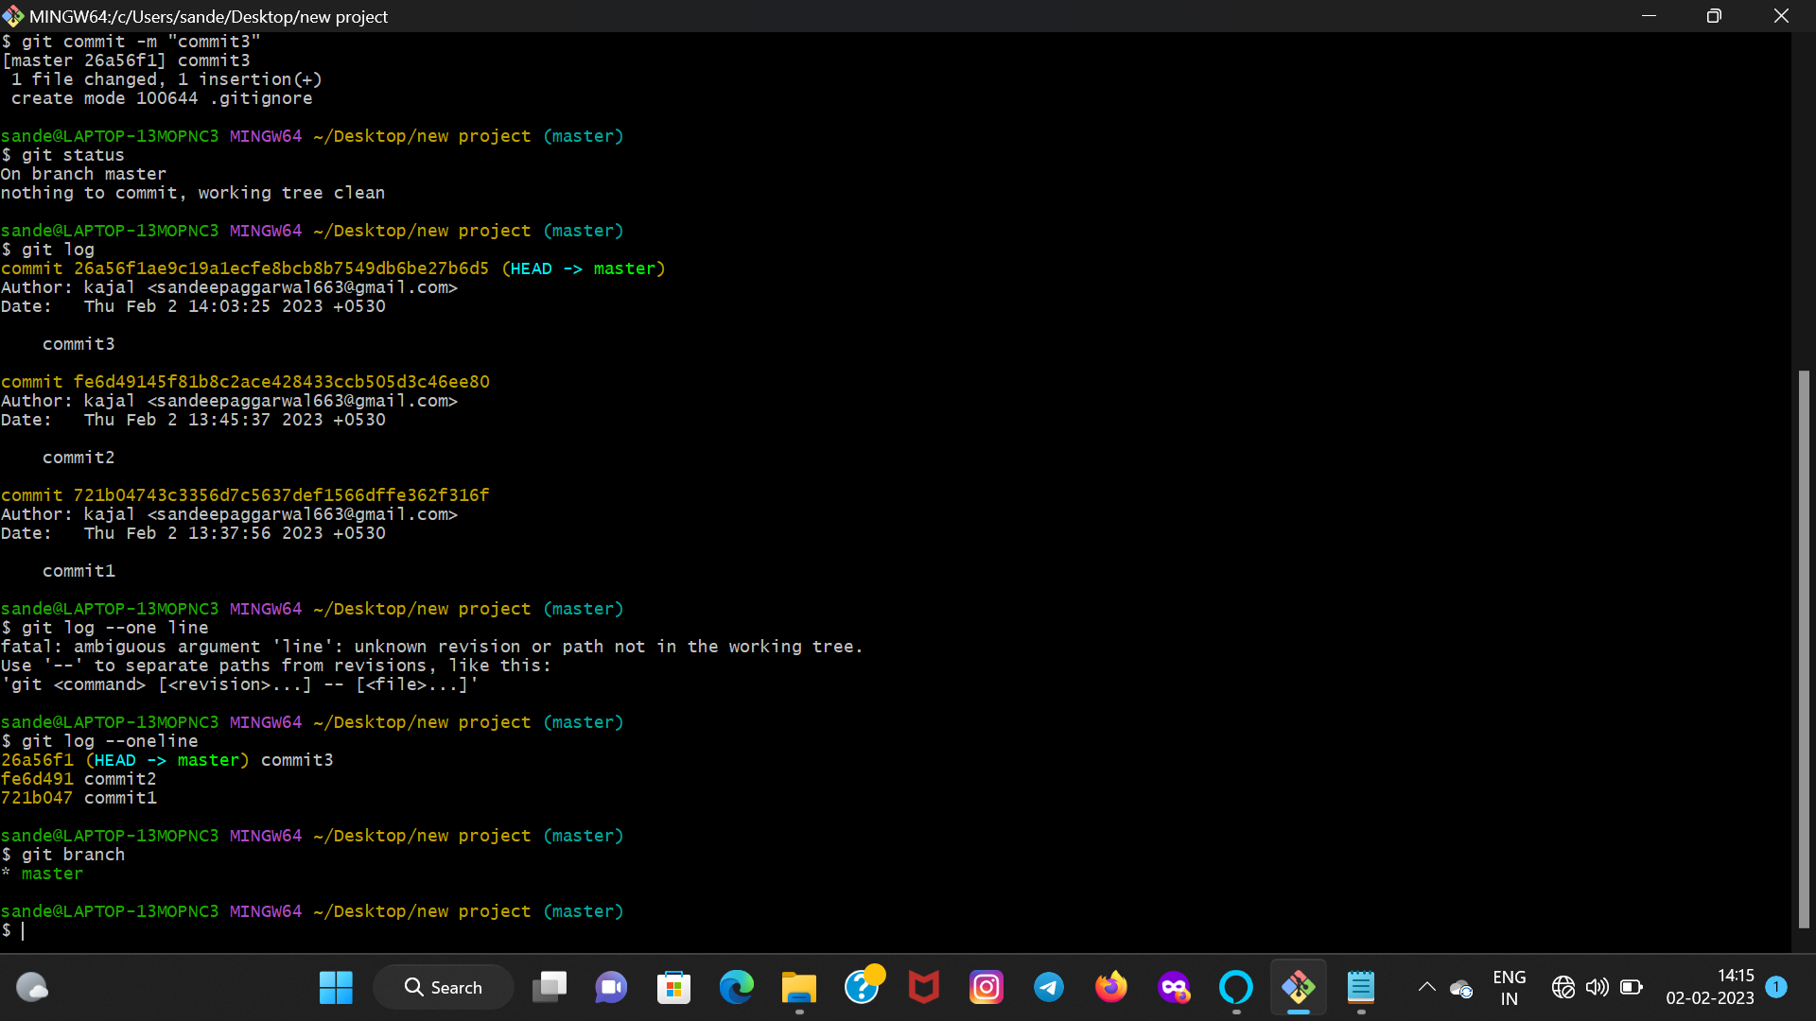

**Result:** We have successfully checked logs

# 

# Experiment 4

**Aim:** Create and visualize branches

**Theory:**

Branching: A branch in Git is an independent line of work (a pointer to a specific commit). It allows users to create a branch from the original code (master branch) and isolate their work. Branches allow you to work on different parts of a project without impacting the main branch.

Create branches: The main branch in git is called as master branch. But we can make branches out of this main master branch. All the files present in master can be shown in branch but the file which are created in branch are not shown in master branch. We can also merge both the parent (master) and child (other branches).

Syntax:

For creating a new branch, git branch name by default is master branch.

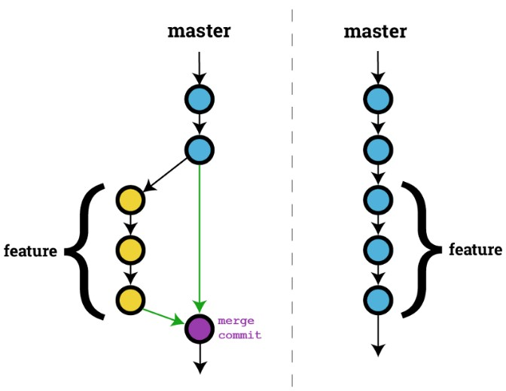

**Snapshots –**

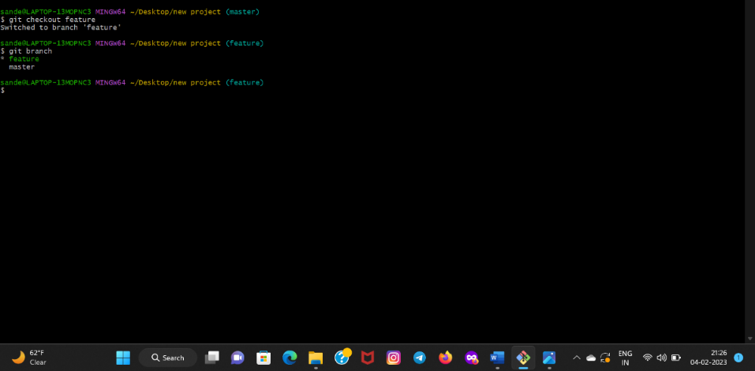

## Adding a feature branch

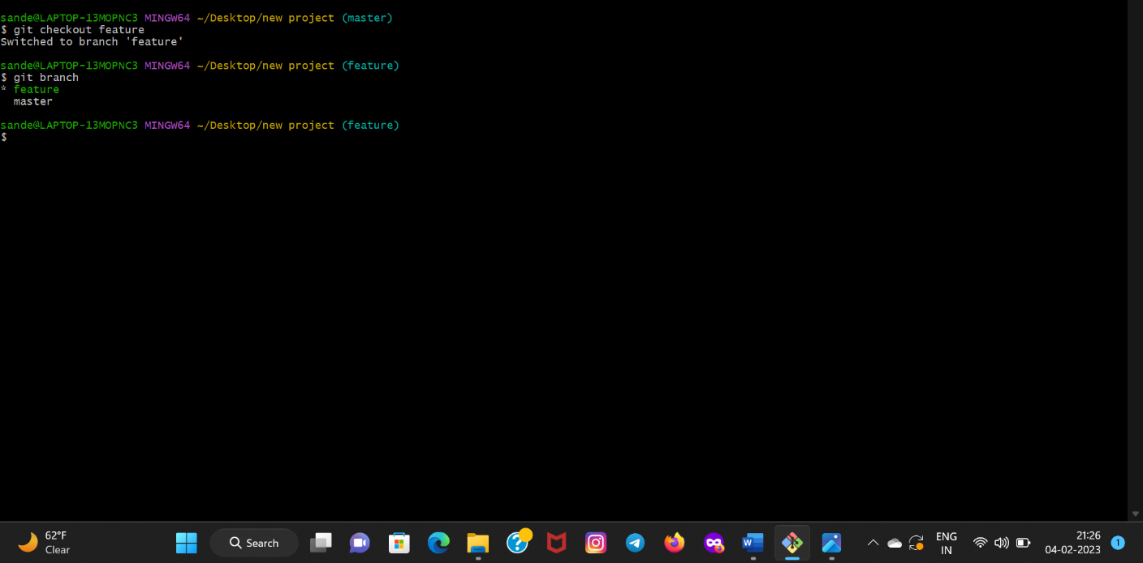

Switching to feature branch

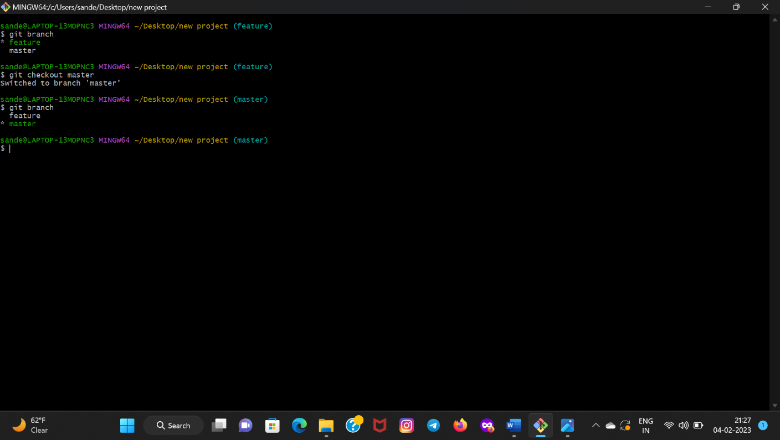

Switching to Master branch

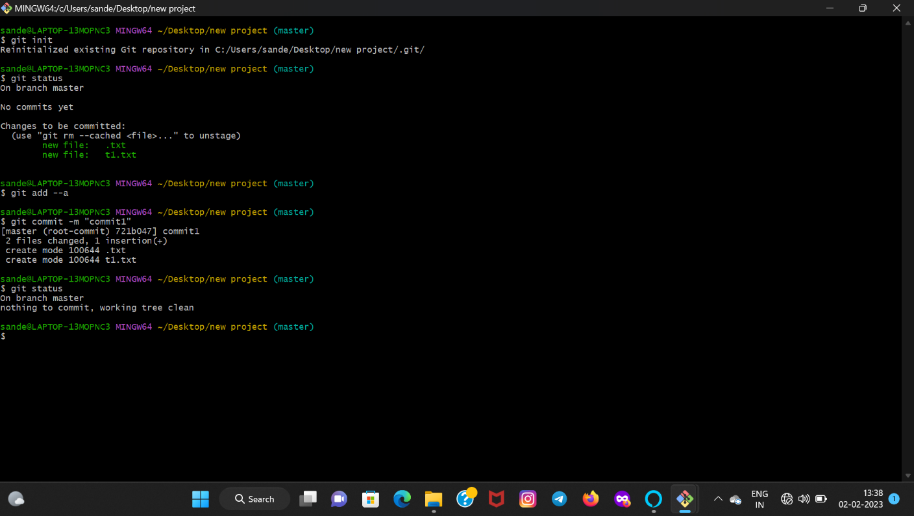

Now if we move to master branch, we will see that these files are untracked in that branch. So,

we merge both branches by using command **“git merge new branch”** and then we write git

status, our working tree will be clean

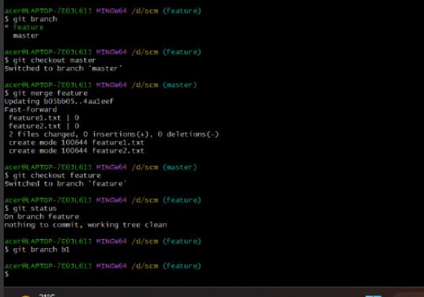

**Result:** We have created a new branch and merged the old and new branch.

# Experiment 5

*Theory:*

**Stages in GIT Life Cycle:** Files in a Git project have various stages like Creation, Modification,Refactoring, and Deletion and so on. Irrespective of whether this project istracked by Git or not, these phases are still prevalent. However, when a projectis under Git version control system, they are present in three major Git statesin addition to these basic ones. Here are the three Git states:

• Working directory

• Staging area

• Git directory

**Working Directory**:

When a project is residing in our local system we don’t know whether the project is tracked by

Git or not. In any of the case, this project directory is called our Working directory.

**Staging Area:**

The staging area is like a rough draft space, it's where you can git add the version of a file or multiple files that you want to save in your next commit (in other words in the next version of your project.

**Git Directory:**

The . git folder contains all information that is necessary for the project and all information relating commits, remote repository address, etc. It also contains a log that stores the commit history. This log can help you to roll back to the desired version of the code

Remote Repository: Remote repositories are hosted on a server that is accessible for all team members - most likely on the internet or on a local network. Assessable and reachable by all.

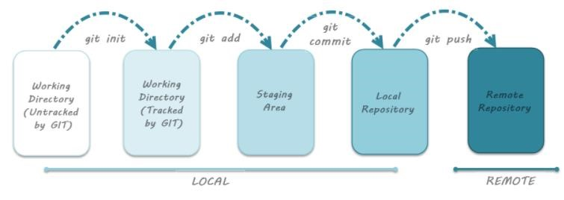

Aim: Git lifecycle description Theory: Stages in GIT Life Cycle: Files in a Git project have various stages like Creation, Modification, Refactoring, and Deletion and so on. Irrespective of whether this project is tracked by Git or not, these phases are still prevalent. However, when a project is under Git version control system, they are present in three major Git states in addition

to these basic ones. Here are the three Git states:

*Working directory

* Staging area

* Git directory

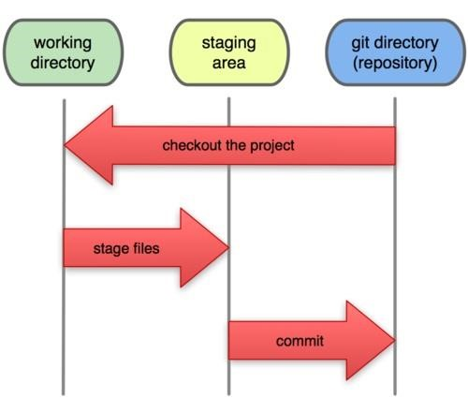

**Working Directory:**

Consider a project residing in your local system. This project may or may not be tracked by Git. In either case, this project directory is called your Working directory.

**Staging Area:**

Staging area is the playground where you group, add and organize the files to be committed to Git for tracking their versions.

**Git Directory:**

Now that the files to be committed are grouped and ready in the staging area, we can commit these files. So, we commit this group of files along with a commit message explaining what is the commit about. Apart from commit message, this step also records the author and time of the commit. Now, a snapshot of the files in the commit is recorded by Git. The information related to this commit is stored in the Git directory.

**Remote Repository:** It means mirror or clone of the local Git repository in GitHub. And pushing means uploading the commits from local Git repository to remote repository hosted in GitHub.



# Experiment No. 06

|  |  |  |
| --- | --- | --- |
|  |  |  |

**Aim:** Add collaborators on GitHub Repo

**Theory:**

Whenever you make a repository in GitHub, not everyone has the permission to change or push codes into your repository. The users have a read-only access. In order to allow other individuals to make changes to your repository, you need to invite them to collaborate to the project.

GitHub also restricts the number of collaborators we can invite within a period of 24 hours. If we exceed the limit, then either we have to wait for 24-hours or we can also create an organization to collaborate with more people.

Being a collaborator, the user can create, merge and close pull requests in the repository. They can also remove them as the collaborator.

**Procedure:**

1. Login to your GitHub account and you will land on the homepage as shown below. Click on Repositories option in the menu bar.

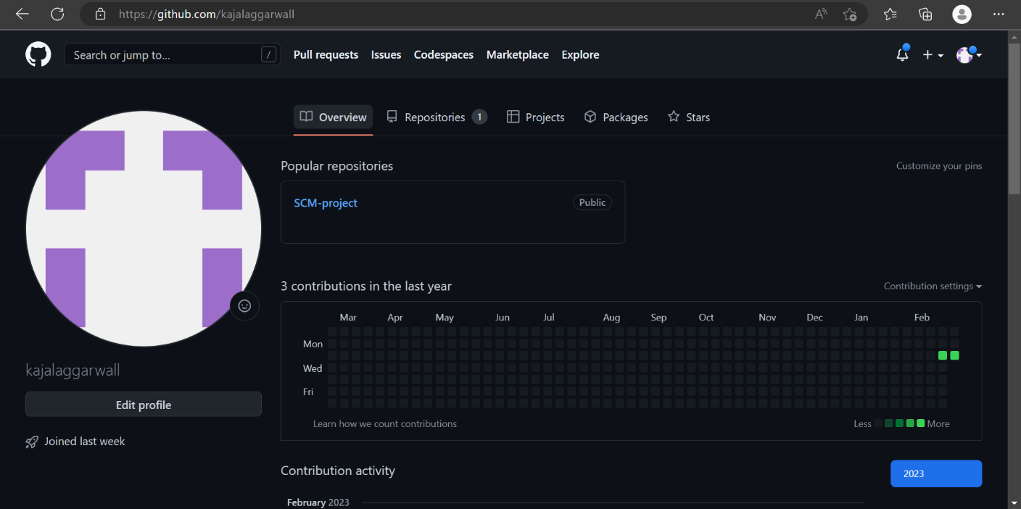

1. Click on the ‘New’ button in the top right corner.

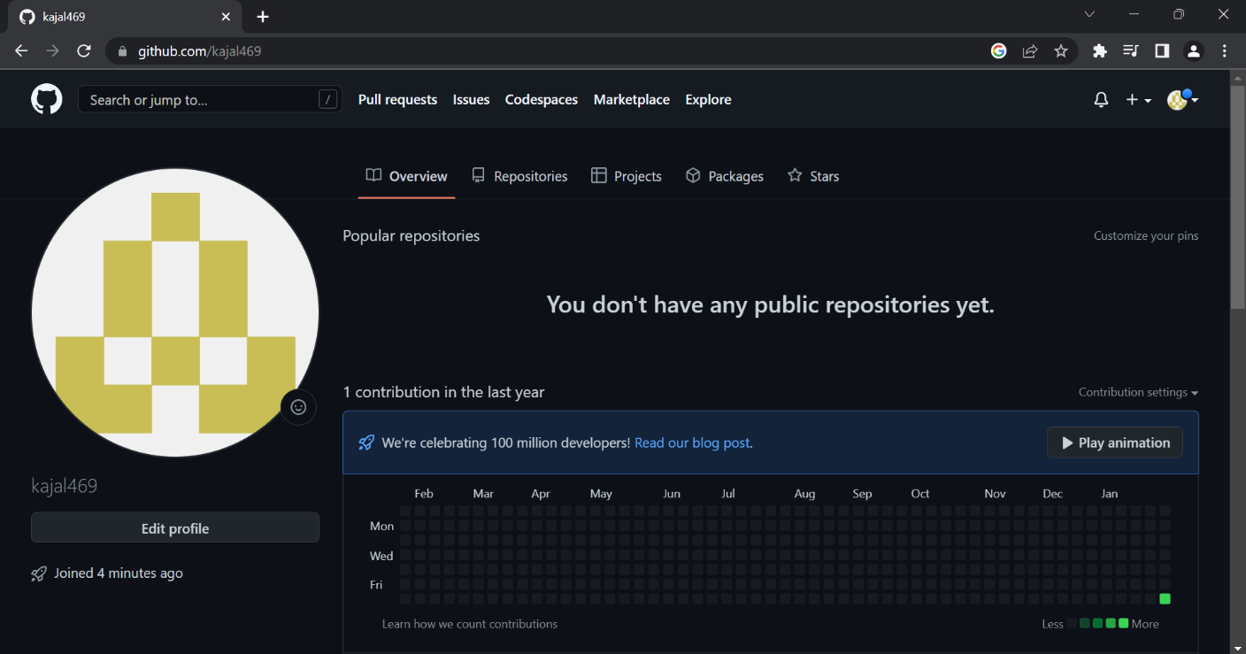

3. Enter the Repository name and add the description of the repository.

4. Select if you want the repository to be public or private.

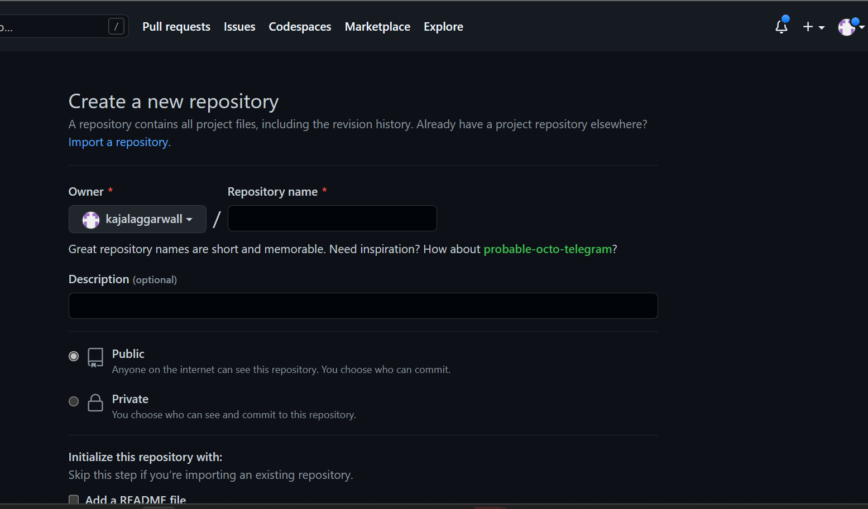

1. If you want to import code from an existing repository select the import code option.

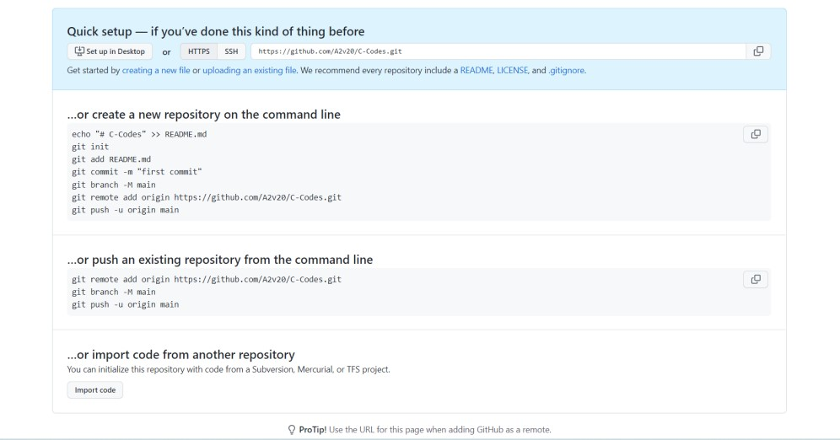

6.Now, you have created your repository successfully.

7.To add collaborators to your repository, open your repository and select settings option in the navigation bar.

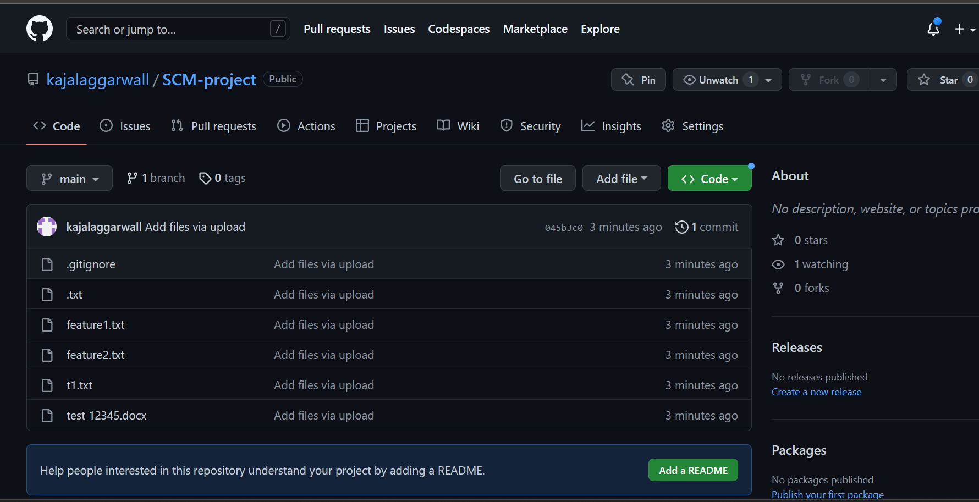

8. Click on Collaborators option under the acess tab.

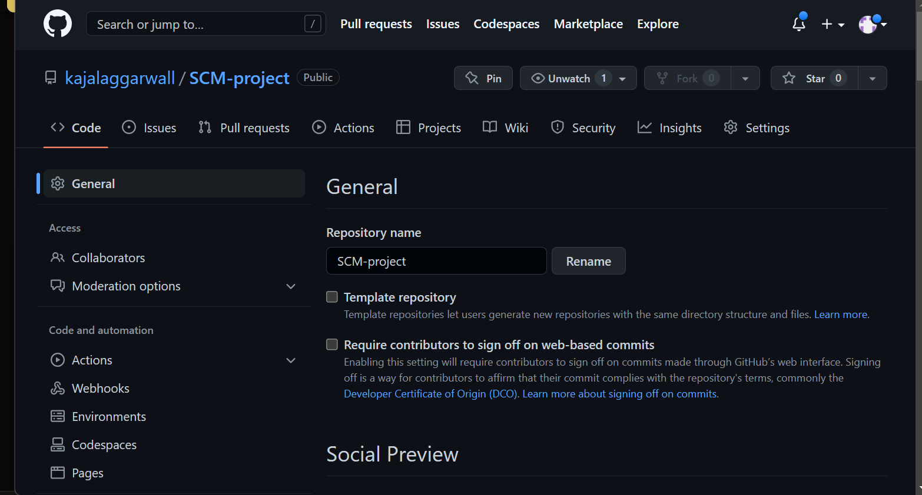

9. After clicking on collaborators, Github asks you to enter your password to confirm the access to the repository.

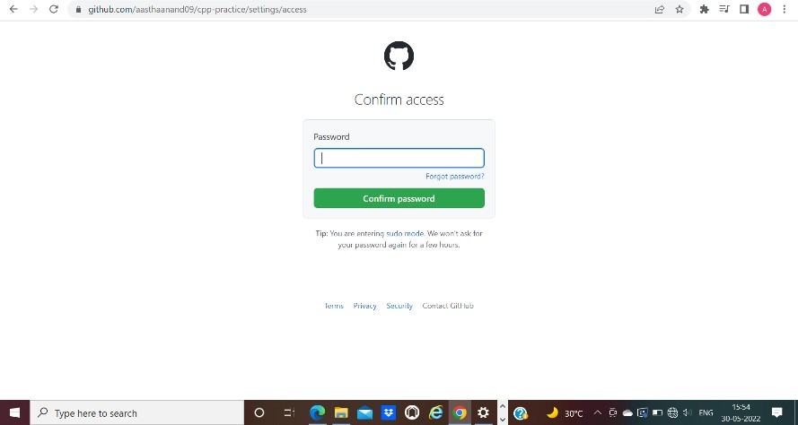

1. After entering the password, you can manage access and add/remove team members to your project.
2. To add members, click on the add people option and search the id of your respective team member.

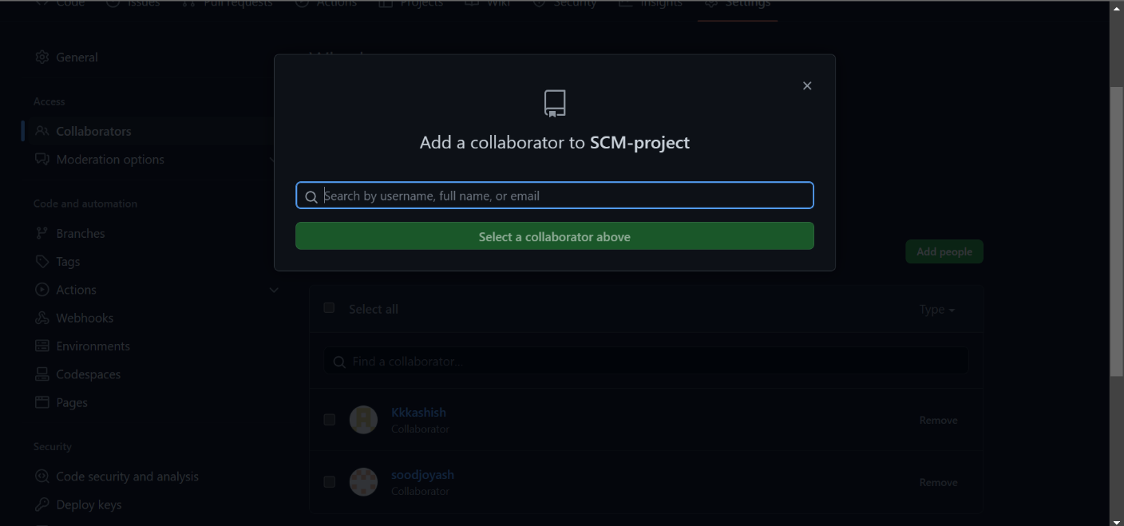

1. To remove any member, click on remove option available in the last column of member’s respective row.

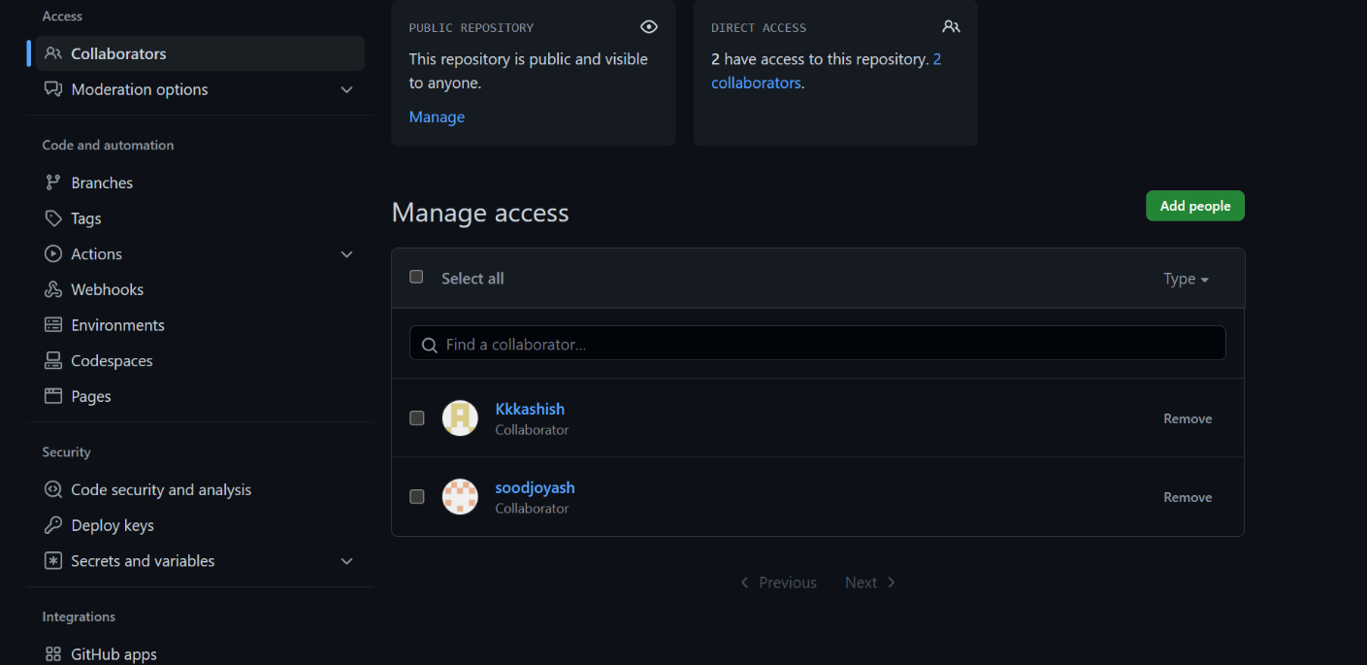

# Experiment No. 07

## **Aim:** Fork and Commit

**Theory:** A fork is a copy of a repository that you manage. It allows us to freely experiment with the data. After creating a fork, we can make any desired change like adding collaborators, rename files, generate GitHub pages but all these changes won’t be reflected in the original repository.

reference for picture: https://www.earthdatascience.org

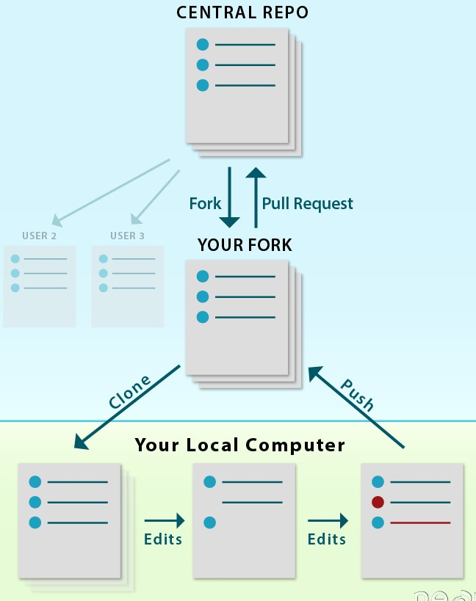

To import the changes into the original repository, the user needs to send a pull request to the maintainer. If the maintainer closes the pull request only then the content can be added to the original repository.

Forking is a better method than directly cloning any repository, as in cloning only the default branch is cloned whereas forking creates a clone of the complete repo and also allows us to push the changes to the main repository by using open and close pull request.

**Procedure:**

1. To fork a repository first thing you need to do is, sign in to your GitHub account and then you come to the repository you want to fork, so here for demo purpose am using **Group01-ChitkaraUniversity/2110990005** repository



1. Click on the **Fork** button on right upside corner. Then it will ask to create a new fork, add description if you want and then click on create fork.

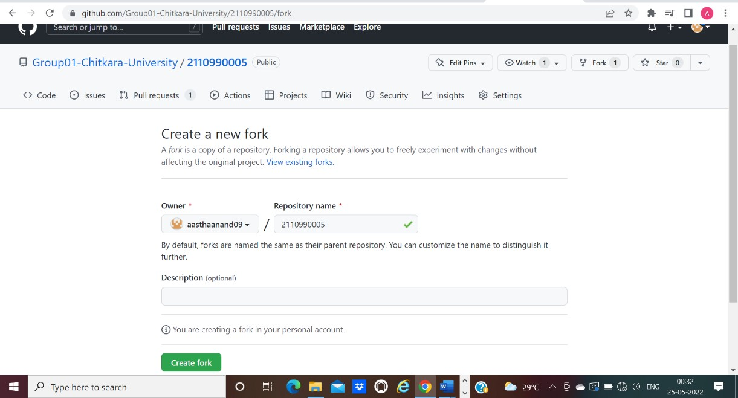

1. Now you will have a copy of the repo you have forked from other user. Now you can do any modification you want without making changes to main source code.

1. Now type git clone [https://github.com/Group01-ChitkaraUniversity/2110990005.git](https://github.com/Group01-Chitkara-University/2110990005.git) on git.

Git clone <url> --> This command is used to fetch the remote repo or to clone the repo.

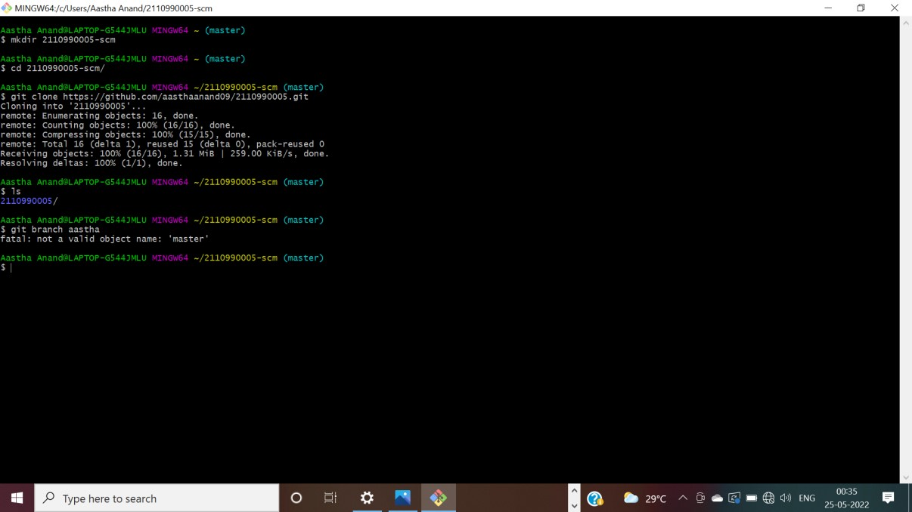

1. Now Open the file make changes in it and commit it and push it to remote.

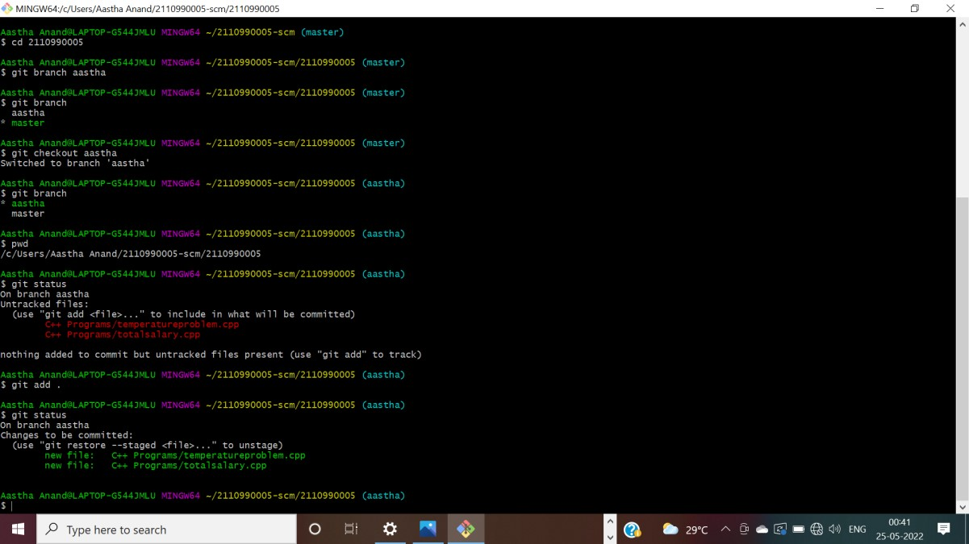

# Experiment No. 8

### 

### Aim: Merge and Resolve conflicts created due to own activity and collaborators activity.

**Theory:**

Version control systems are all about managing contributions between multiple distributed authors (usually developers). Sometimes multiple developers may try to edit the same content. If Developer A tries to edit code that Developer B is editing a conflict may occur.

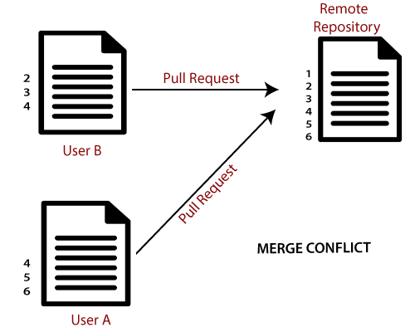

reference for picture: https://www.javatpoint.com/git-merge-and-merge-conflict

If you have a merge conflict on the command line, you cannot push your local changes to GitHub until you resolve the merge conflict locally on your computer.

To alleviate the occurrence of conflicts developers will work in separate [isolated branches.](https://www.atlassian.com/git/tutorials/using-branches) If a merge conflict still arises between the compare branch and base branch in your pull request, you can view a list of the files with conflicting changes above the Merge pull request button. The Merge pullrequest button is deactivated until you've resolved all conflicts between the compare branch and base branch.

**Procedure:**

1) Do changes in master branch and commit those change. And checkout to different branch and again do changes and commit it. Now checkout

to master branch and merge that branch in master.

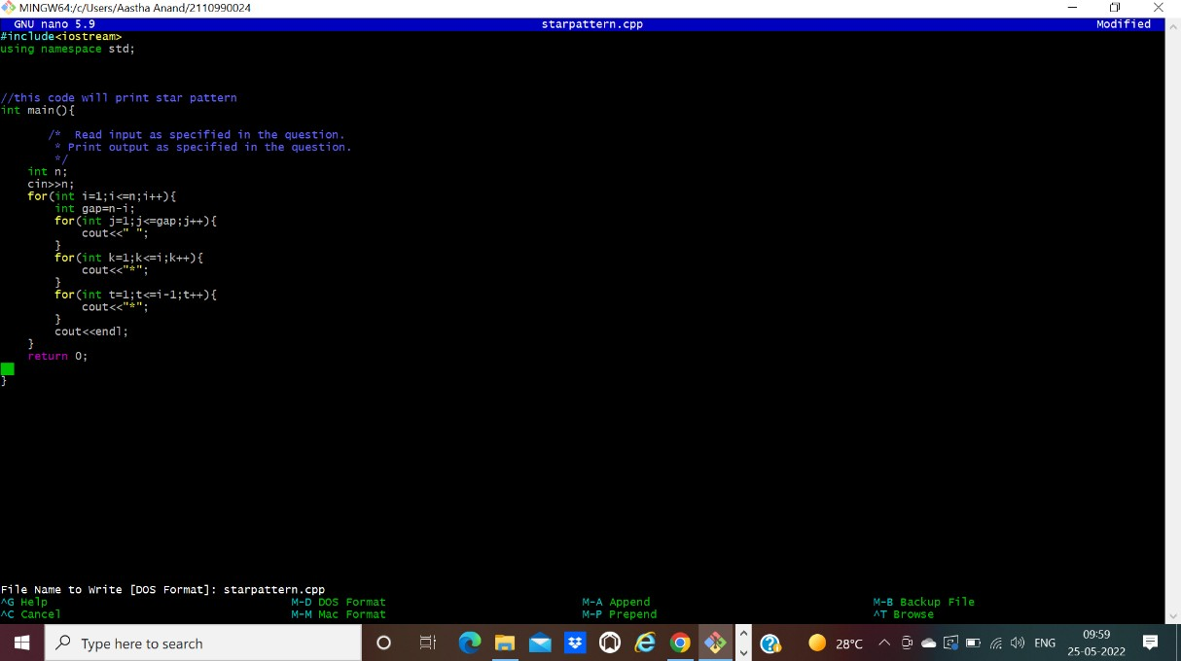

Now try to merge it will give Conflicts Error.

Use Command “git merge tool” to solve the conflict.

Git -merge tool – Run merge conflict resolution tools to solve merge conflicts.

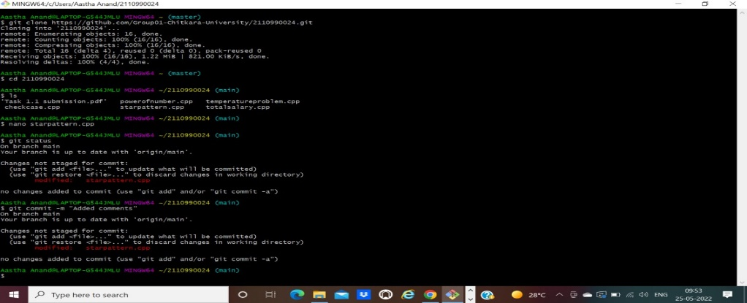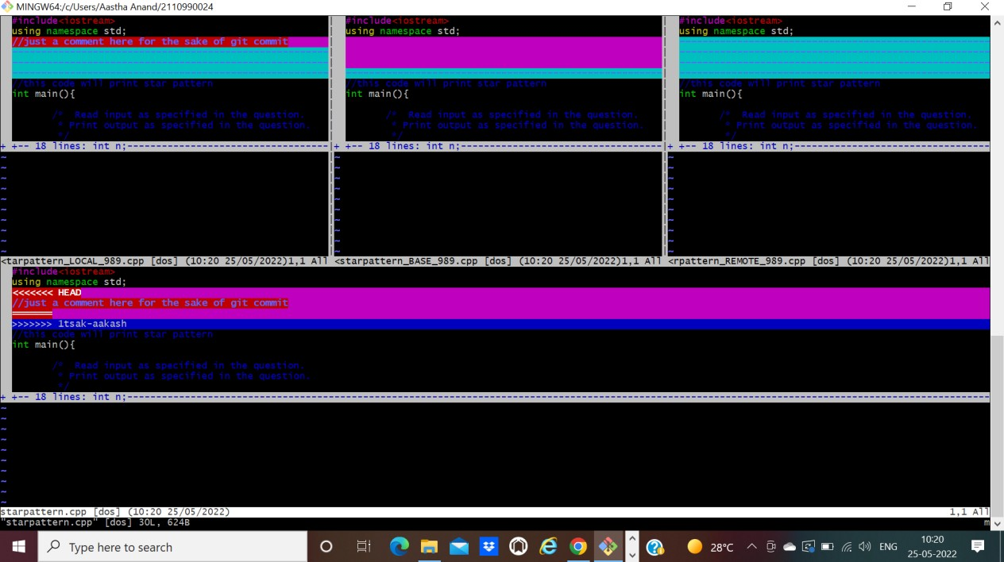

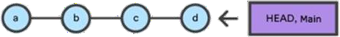**Experiment No. 9**

**Aim:** Reset and Revert

A reset is an operation that takes a specified commit and resets the "three trees" to match the state of the repository at that specified commit. A reset can be invoked in three different modes which correspond to the three trees. In reset, rest of the commits wash out after the mentioned commit. This is a limitation of reset command that we cannot have any random access.

A revert is an operation that takes a specified commit and creates a new commit which inverses the specified commit. git revert can only be run at a commit level scope and has no file level functionality.

These two features justify the Version- controlled feature of the git as we can rollback to any version at any time.

### PROCEDURE:

Firstly, prepare a log of multiple commits to make the reset and revert command function.

**Reset:** reset is the command we use when we want to move the repository back to a previous commit, discarding any changes made after that commit.

* 1. Create few files, stage them and commit.
  2. Check the git log

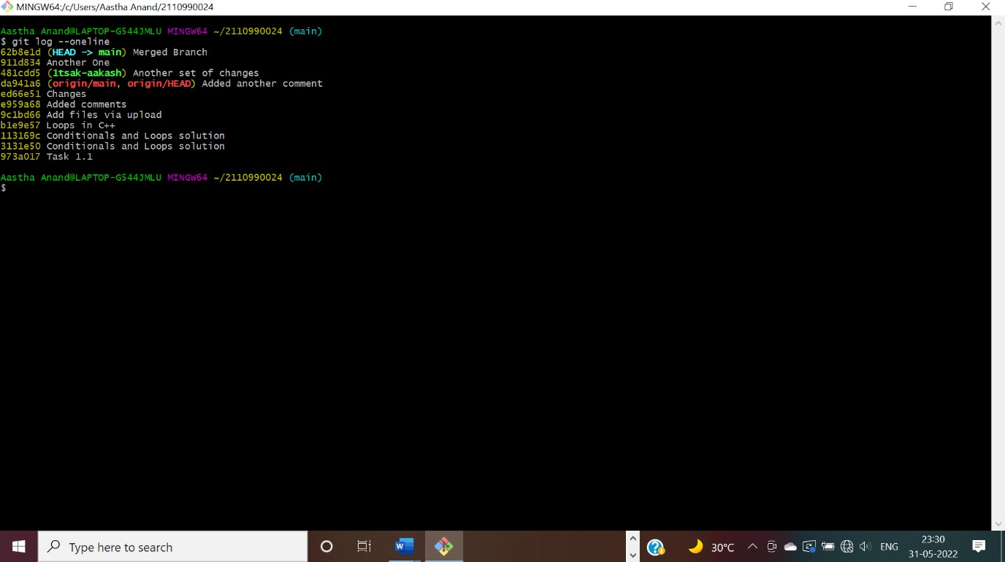

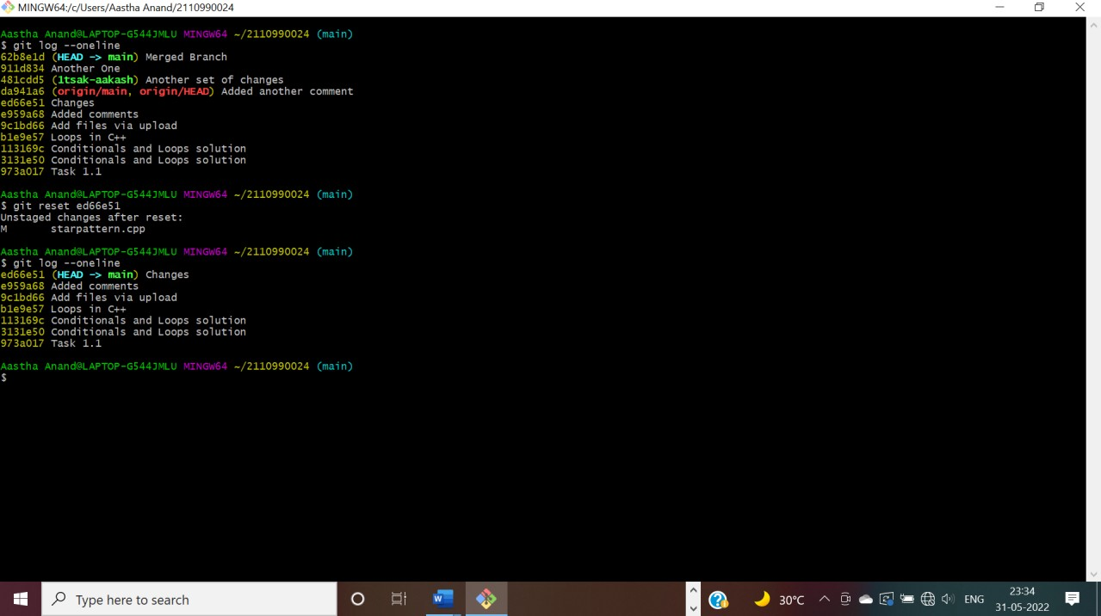

The head is now pointing the commit whose checksum we have

provided that means the commits that followed vanished.

In you want undo this change, you copy the checksum of the

commit you want back and run the same command again.

### Revert:

Follow these steps to revert any change:

* + 1. Pick the change where you want the project to revert back. Copy its checksum and paste it in the revert

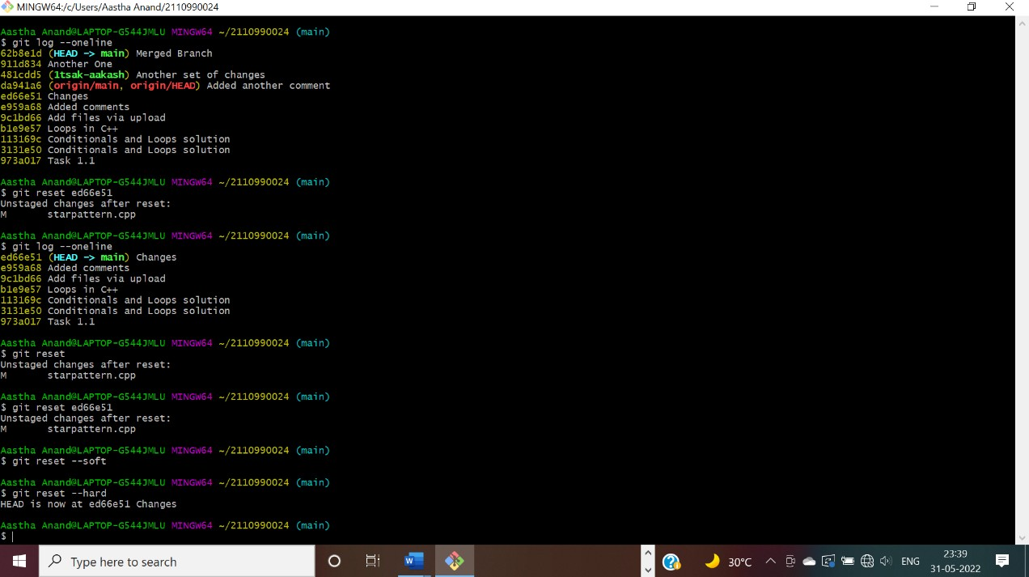

command

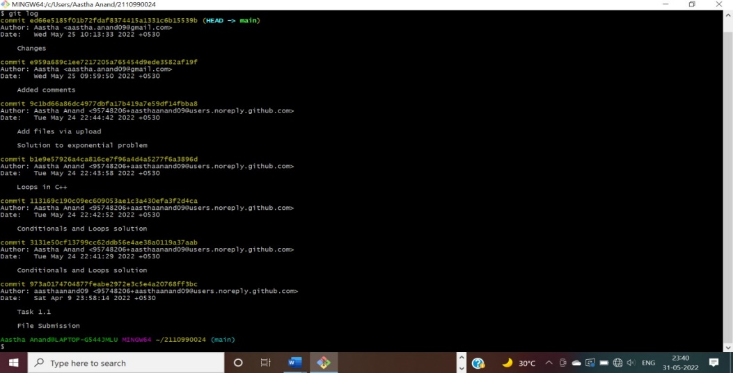

A window will appear. Press ‘I” and write the statement you want to be displayed for reverting the change.

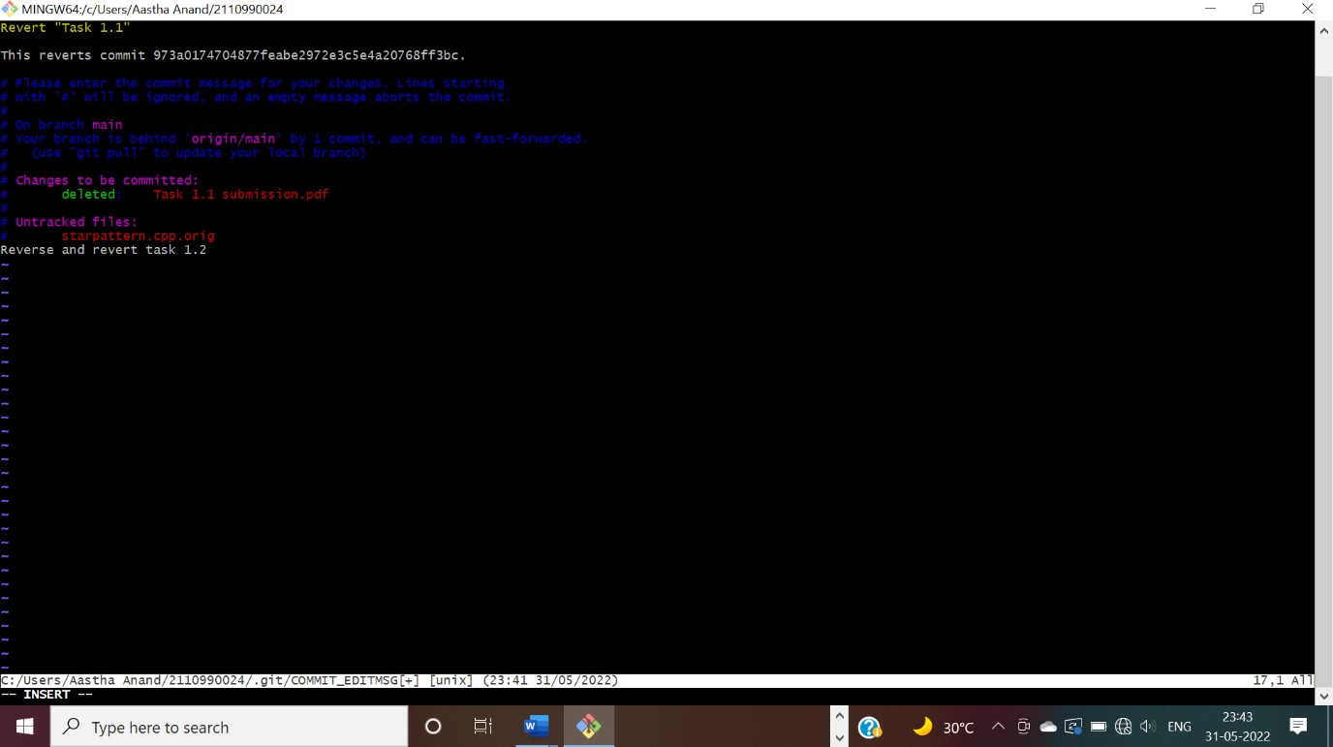

After completing press ‘esc’ and write: wq in the terminal.

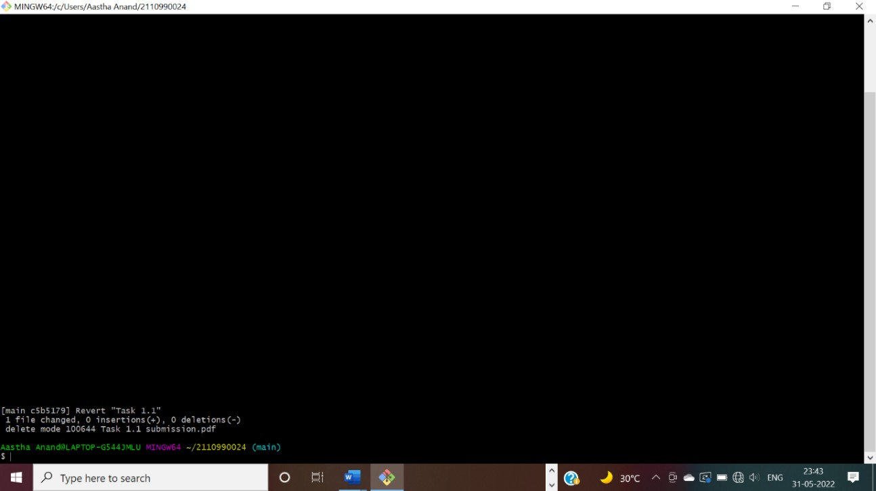

Check the git log and you will find another commit is added without affecting the rest commits.

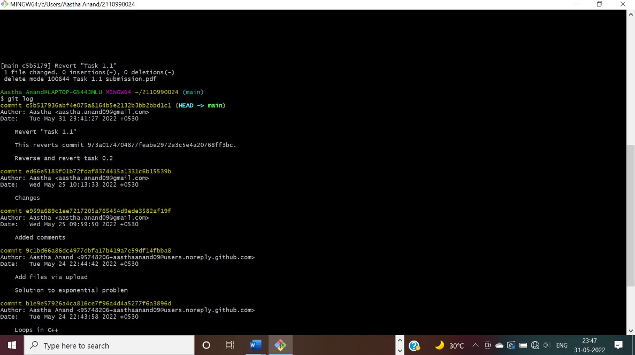

The change associated to the reverted com

A Project report on

# “Task 2”

with

# Source Code Management

(22CS003)

**Submitted by:**

Kajal

Roll No. 221090469

# Submitted To:

Dr. Chetna Kaushal

Assistant Professor

Department of Computer Science and Engineering,

Chitkara University Institute of Engineering and Technology, Chitkara University, Punjab

Team Member 1 Name: Joyash Sood Roll No. 2210990466

Team Member 2 Name: Kajal Roll No. 2210990469

Team Member 3 Name: Kashish Roll No. 2210990494

Institute/School: **Chitkara University Institute of Engineering and** **Technology**

Department Name: **Department of Computer Science & Engineering**

|  |  |  |  |
| --- | --- | --- | --- |
| Program Name: | **Bachelor of Engineering (B.E.), Computer Science &** | | |
| **Engineering** |  |  |
| Course Name: | **Source Code** |  | Session: **2023-24** |
| Course Code:  Vertical Name: | **Management**  **22CS003**  **First Year** |  | Semester/Batch: **1st** **/2023**  Group No: **G24-B** |

Faculty Name: **Dr. Chetna Kaushal**

**Assistant professor**

# INDEX

|  |  |  |
| --- | --- | --- |
| **S. NO** | **Experiment Name** | **Page No.** |
| 1. | Introduction | 39 |
| 2. | Problem statement | 42 |
| 3. | Solution | 43 |
| 4. | Objective | 42 |
| 5. | Create a distributed Repository and add members in project team | 44 |
| 6. | Open and close a pull request | 50 |
| 7. | Create a pull request on a team members repo and close pull requests generated by team members on own Repo as a maintainer | 54 |
| 8. | Publish and print network graphs | 58 |

**Introduction:**

|  |  |  |
| --- | --- | --- |
|  |  |  |

What is GIT and why is it used?

Git is a version control system that is widely used in the programming world. It is used for tracking changes in the source code during software development. It was developed in 2005 by Linus Torvalds, the creator of the Linux operating system kernel.

Git is a speedy and efficient distributed [VCS](https://www.w3docs.com/learn-git/version-control-software.html) tool that can handle projects of any size, from small to very large ones. Git provides cheap local branching, convenient staging areas, and multiple workflows. It is free, open-source software that lowers the cost because developers can use Git without paying money. It provides support for non-linear development. Git enables multiple developers or teams to work separately without having an impact on the work of others.

Git is an example of a distributed version control system (DVCS) (hence Distributed Version Control System).

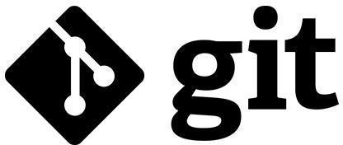

What is GITHUB?

It is the world’s largest open-source software developer community platform where the users upload their projects using the software Git.

|  |  |  |
| --- | --- | --- |
|  |  |  |

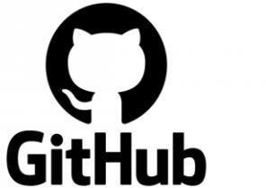

What is the difference between GIT and GITHUB?

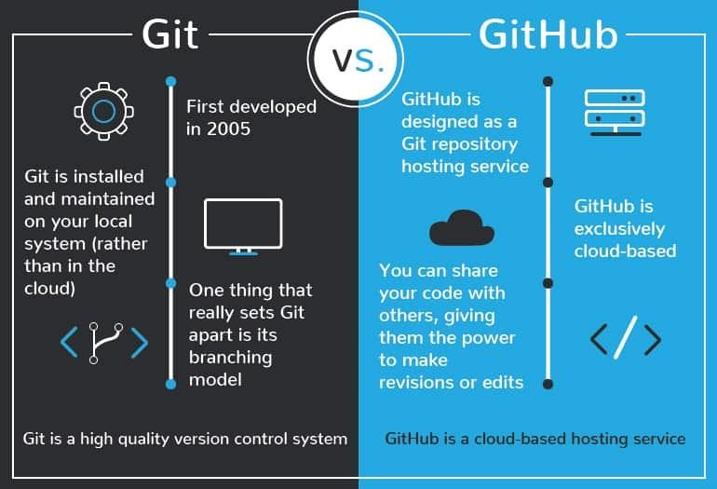

What is Repository?

A repository is a directory or storage space where your projects can live. Sometimes GitHub users shorten this to “repo.” It can be local to a folder on your computer, or it can be a storage space on GitHub or another online host. You can keep code files, text files, image files, you name it, inside a repository.

What is Version Control System (VCS)?

A version control system is a tool that helps you manage “versions” of your code or changes to your code while working with a team over remote distances. Version control keeps track of every modification in a special kind of database that is accessible to the version control software. Version control software (VCS) helps you revert back to an older version just in case a bug or issue is introduced to the system or fixing a mistake without disrupting the work of other team members.

Types of VCS

Local Version Control System

Centralized Version Control System

Distributed Version Control System

**Local Version Control System:** Local Version

Control System is located in your local machine. If the local machine crashes, it would not be possible to retrieve the files, and all the information will be lost. If anything happens to a single version, all the versions made after that will be lost.

**Centralized Version Control System:** In the Centralized Version Control Systems, there will be a single central server that contains all the files related to the project, and many collaborators checkout files from this single server (you will only have a working copy). The problem with the Centralized Version Control Systems is if the central server crashes, almost everything related to the project will be lost.

**Distributed Version Control System:** In a distributed version

control system, there will be one or more servers and many collaborators similar to the centralized system. But the difference is, not only do they check out the latest version, but each collaborator will have an exact copy of the main repository on their local machines. Each user has their own repository and a working copy. This is very useful because even if the server crashes we would not lose everything as several copies are residing in several other computers.

## **Problem Statement**

“Build a website and deploy it on GitHub” Many a times, while travelling we get into certain unforeseen situations where we run out of fuel or our vehicle gets overheated. On a deserted road, the possibility of finding a petrol pump nearby or a mechanic is negligible. In a situation like this we would need someone to provide assistance to help us get out of that situation. Here comes "Serve U” addressing the real time vehicle breakdown problems of customers in day-to-day life.

## Solution

Vehicle Servicing, Vehicle repairs and Car cleaning - we are your one- stop solution for all things cars. Serve U intends to be the best roadside assistance provider in India by addressing the real time vehicle breakdown problems of customers in day-to-day life. A brainchild of 5 friends – A adarsh Kumar, Aakash Jha, Aastha Anand, A ayushi Jain and Abhimanyu Nain, Serve U is a network of technology-enabled automobile service centres, offering a seamless car and bike service experience at the convenience of a tap. With our highly skilled technicians, manufacturer recommended procedures and the promise of genuine spare parts we are your best bet. Stay in the comforts of your home or office and make the most of our complimentary pick-up and drop-in service. Count on us to be your personal vehicle care expert, advisor and mechanic.

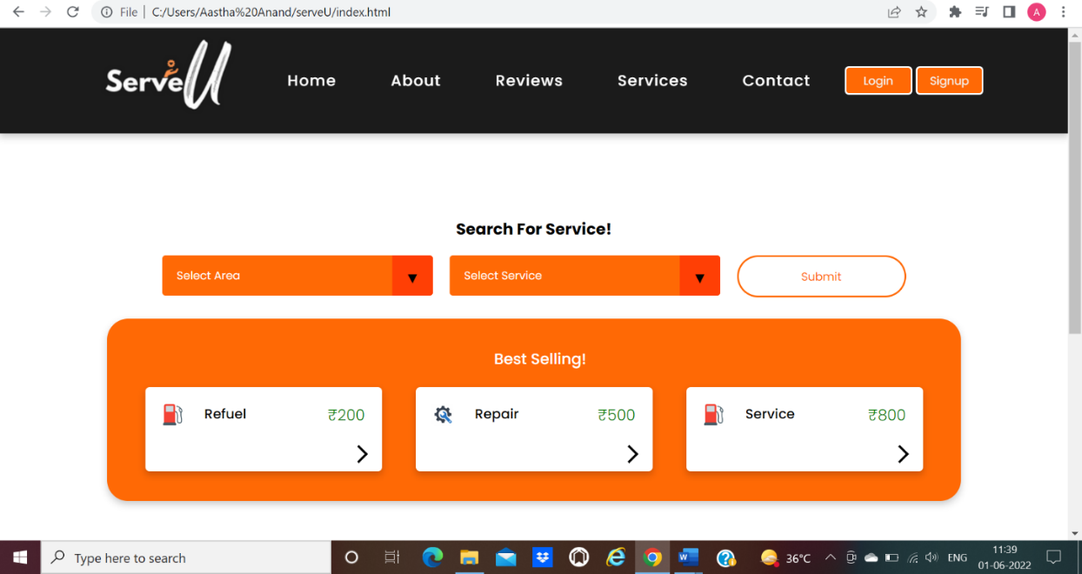

## Objective:

The objective of this project is to associate programming with git because:

1. This is required because the collaboration makes the team work easy.
2. The code becomes manageable and we can build a clean repository.
3. Tracking and resolving of the errors is quite feasible in this process.
4. Moreover, we can make our locally available projects, globally available.

# Experiment No. 1:

Aim: Create a distributed Repository and add members in project team

Login to your GitHub account and you will land on the homepage as shown below. Click on Repositories option in the menu bar.

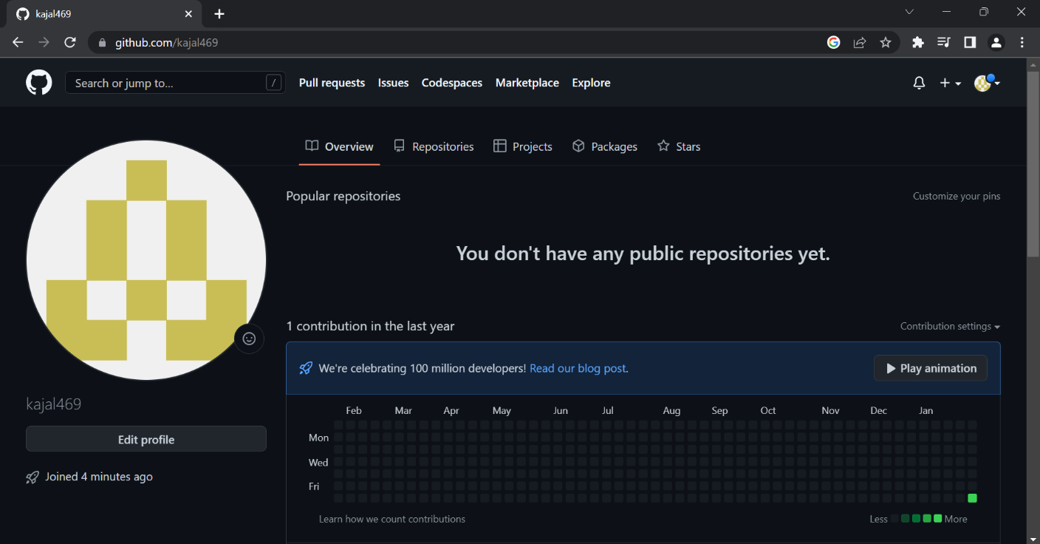

Click on the ‘New’ button in the top right corner.

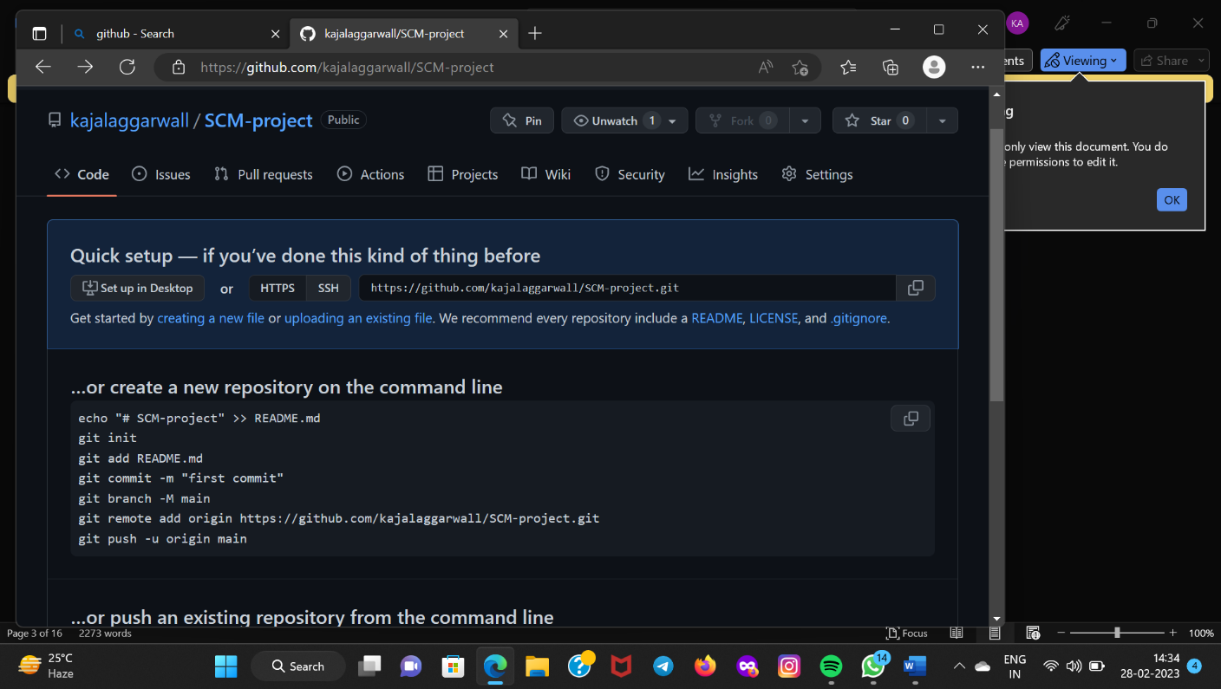

Enter the Repository name and add the description the repository.

Select if you want the repository to be public or private.



If you want to import code from an existing repository select the import code option.

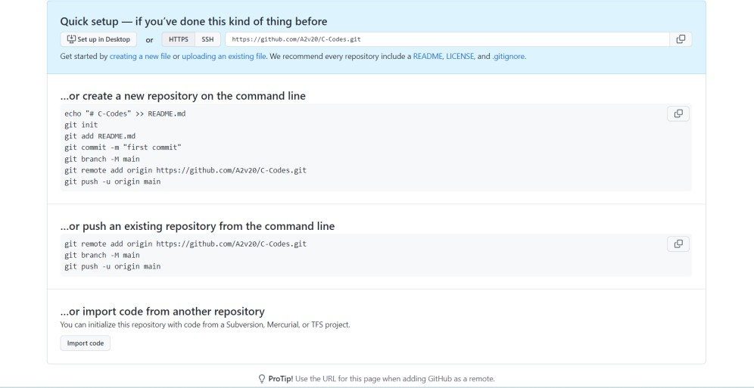

Now, you have created your repository successfully.

To add members to your repository open your repository and select settings option in the navigation bar.

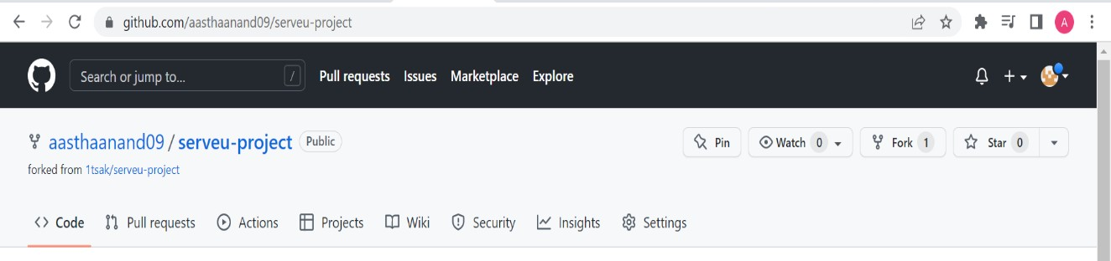

Click on Collaborators option under the access tab.

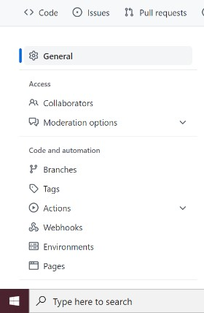

After clicking on collaborators GitHub asks you to enter your password to confirm the access to the repository

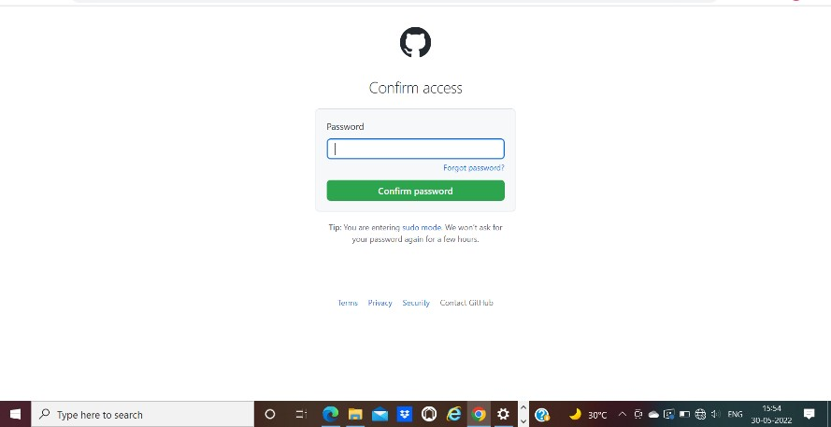

After entering the password you can manage access and add/remove team members to your project.

To add members click on the add people option and search the id of your respective team member.



To remove any member click on remove option available in the last column of member’s respective row.



To accept the invitation from your team member, open your mail registered with GitHub. You will receive an invitation mail from the repository owner. Open the email and click on accept invitation. You will be redirected to

GitHub where you can either select to accept or decline the invitation.

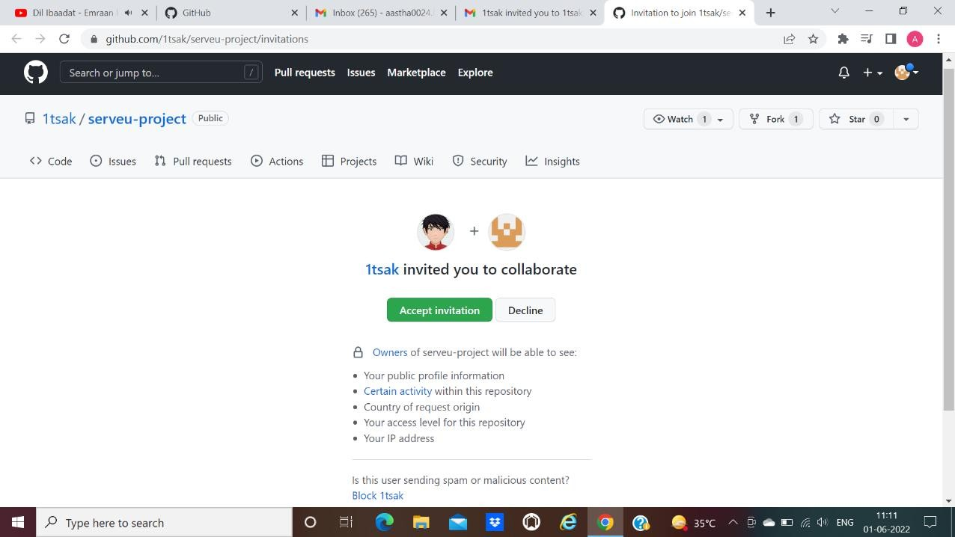

You will be shown the option that you are now allowed to push. Now all members are ready to contribute to the project.

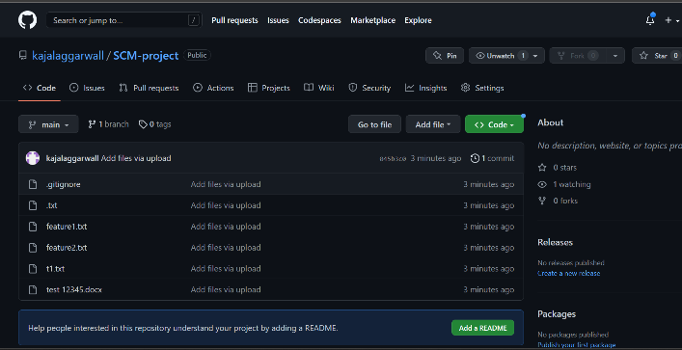

# Experiment No.2

Aim: Open and Close a Pull Request

To open a pull request we first have to make a new branch, by using git branch *branch name* option.

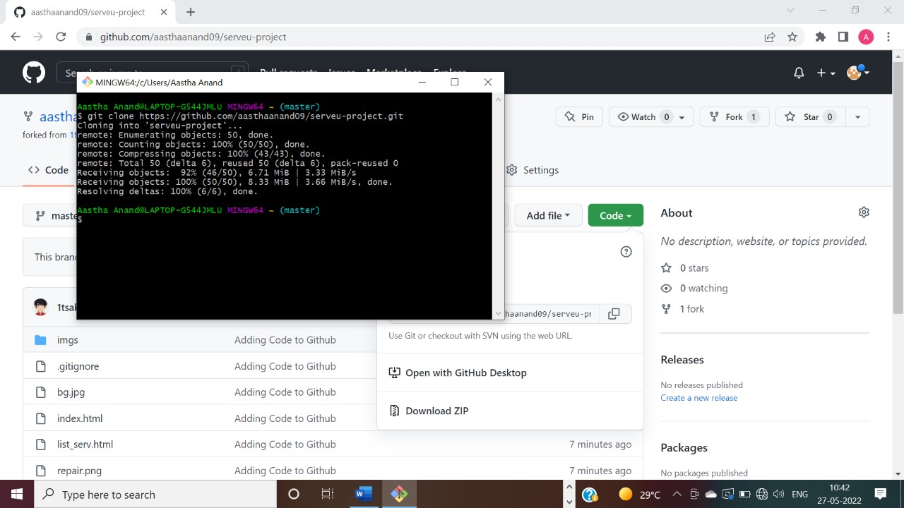

After making new branch we add a file to the branch or make changes in the existing file.

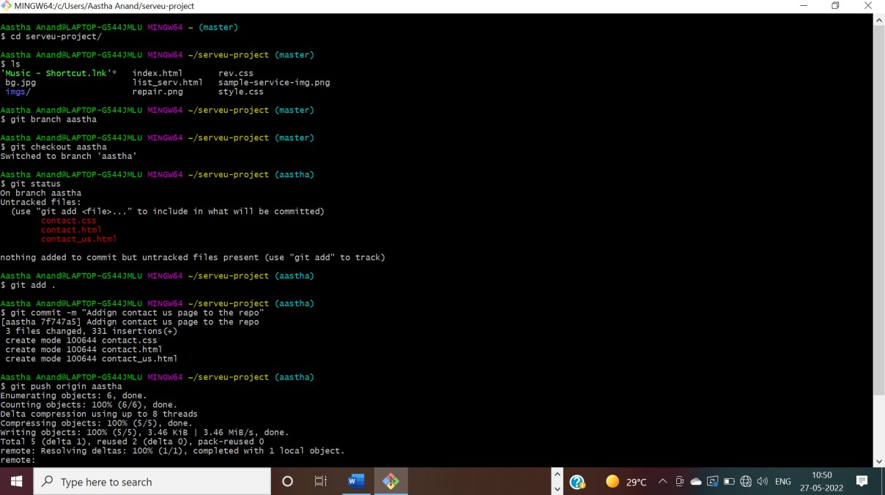

Add and commit the changes to the local repository.Use git push origin *branchname* option to push the new branch to the main repository.

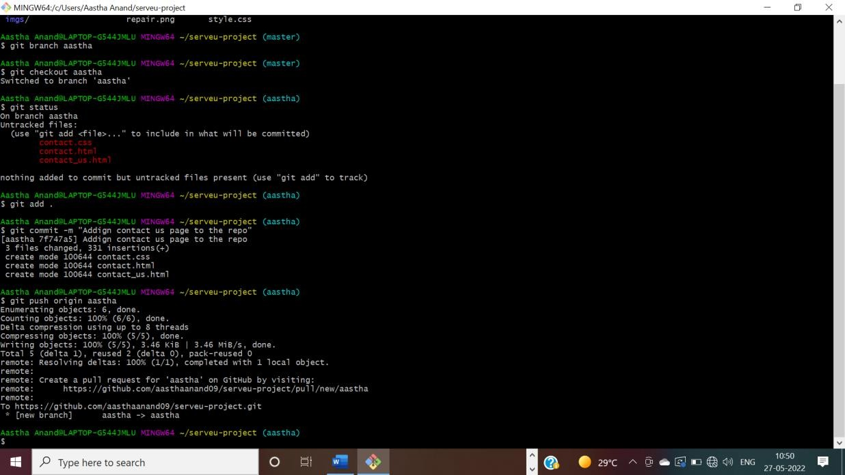

After pushing new branch GitHub will either automatically ask you to create a pull request or you can create your own pull request.

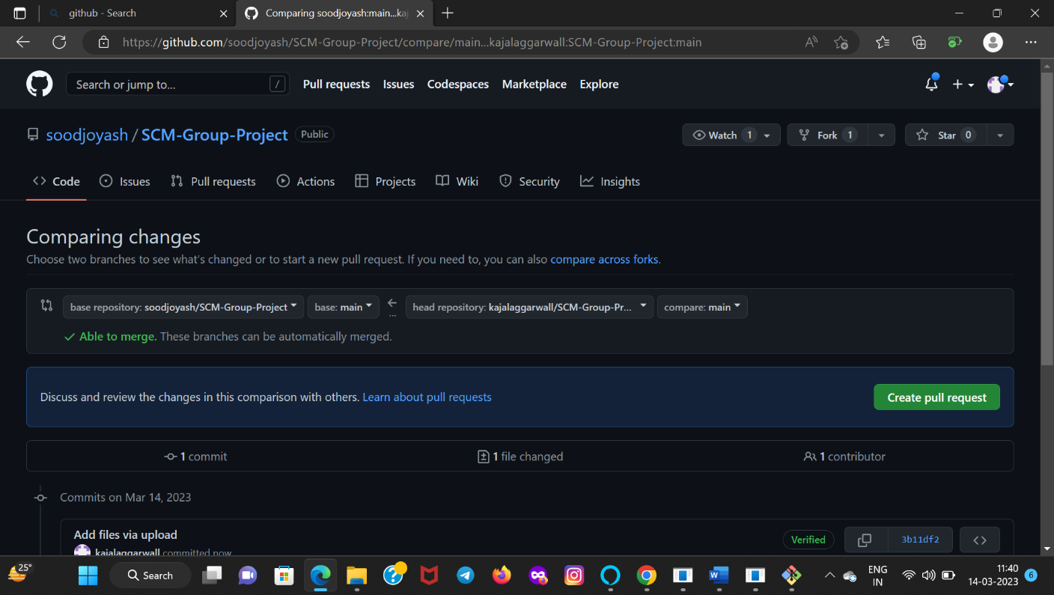

To create your own pull request, click on pull request option.

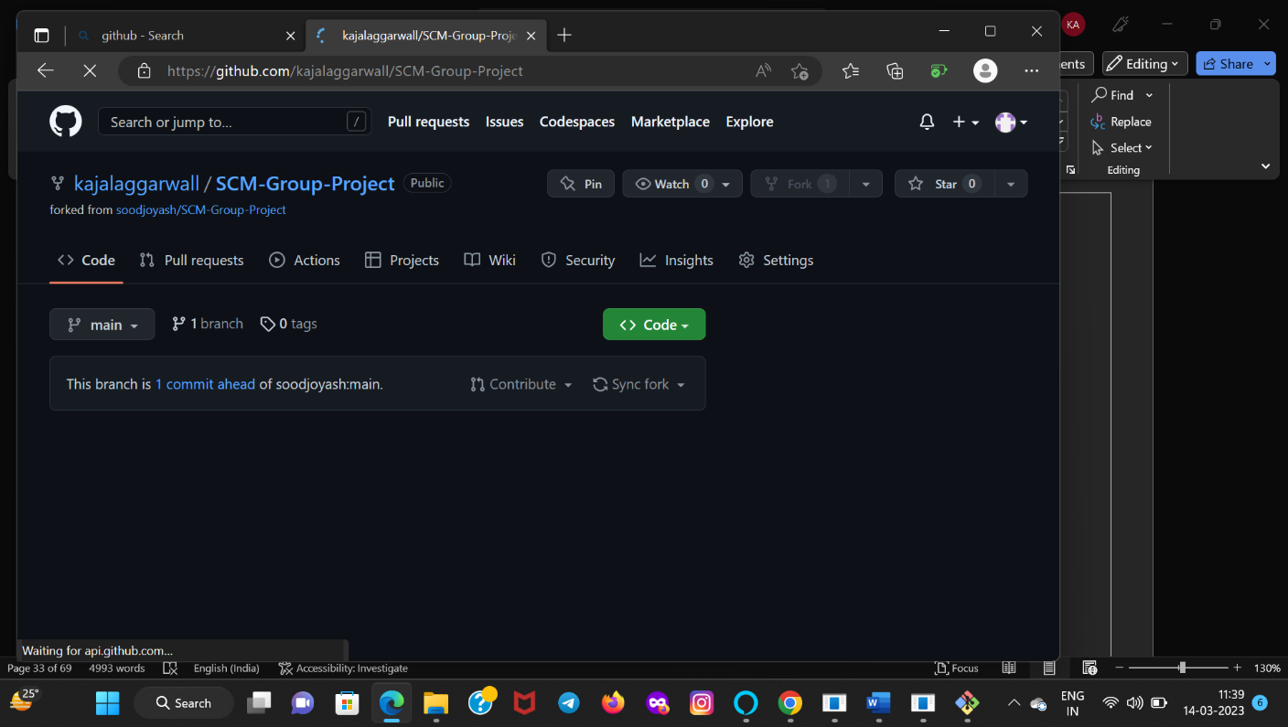

GitHub will detect any conflicts and ask you to enter a description of your pull request.



After opening a pull request all the team members will be sent the request if they want to merge or close the request.

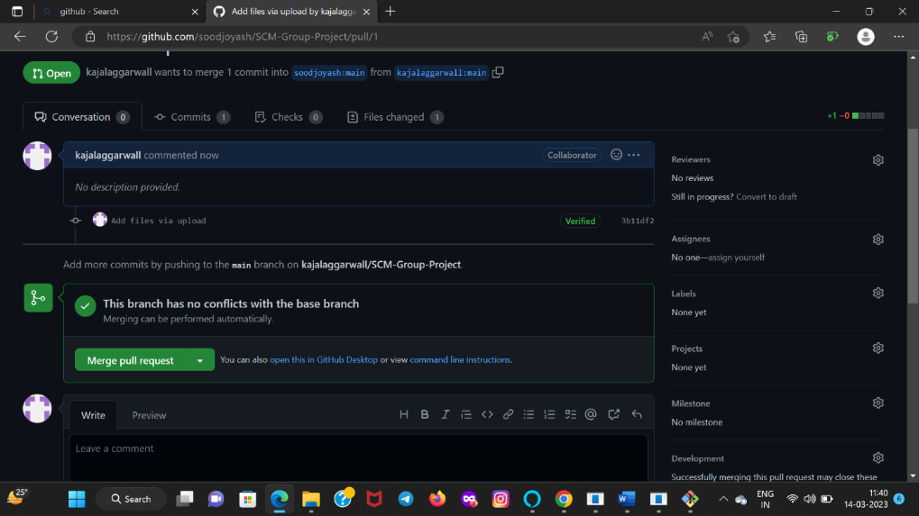

If the team member chooses not to merge your pull request they will close your pull request. To close the pull request simply click on close pull request and add comment/ reason why you closed the pull request. You can see all the pull request generated and how they were dealt with by clicking on pull request option.

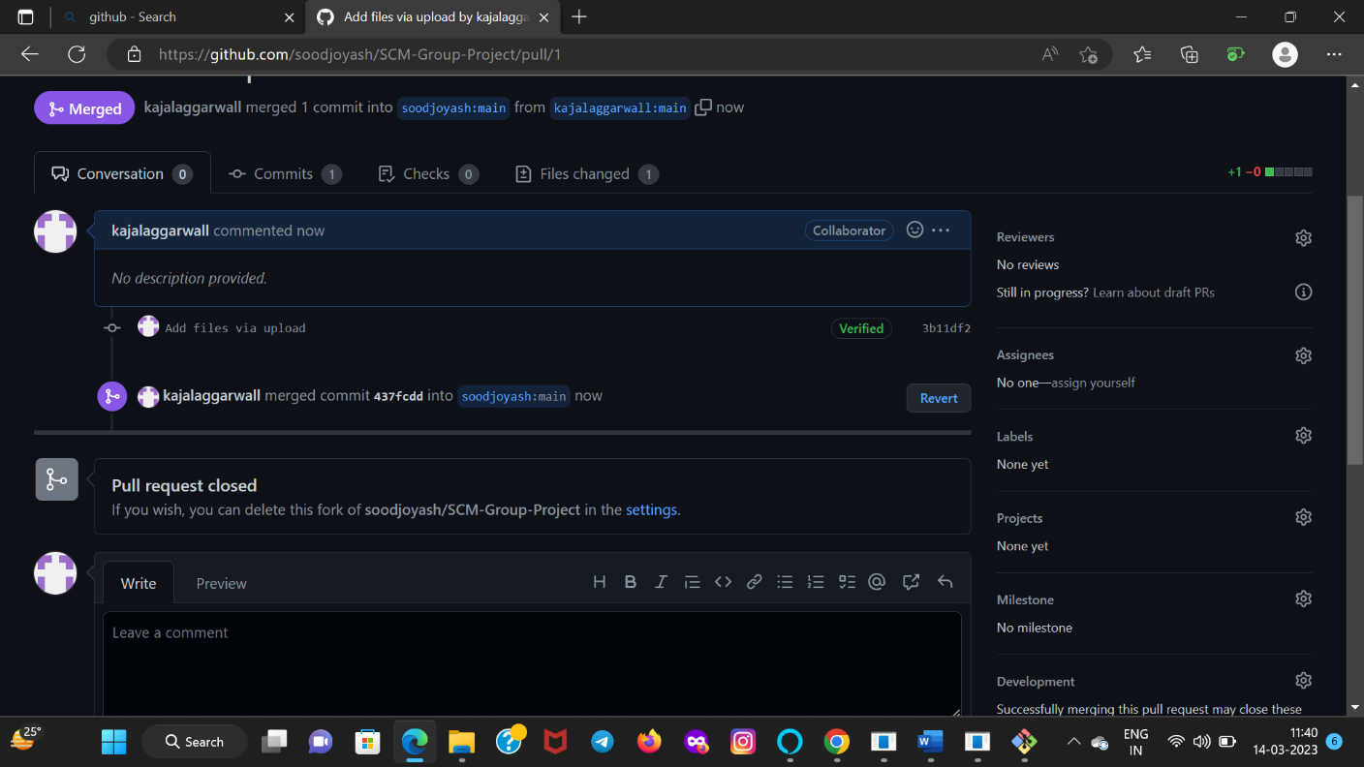

# Experiment No.3

Aim: Create a pull request on a team member’s repo and close pull requests generated by team members on own Repo as a maintainer.

To create a pull request on a team member’s repository and close requests by any other team members as a maintainer follow the procedure given below:

Do the required changes in the repository, add and commit these changes in the local repository in a new branch.

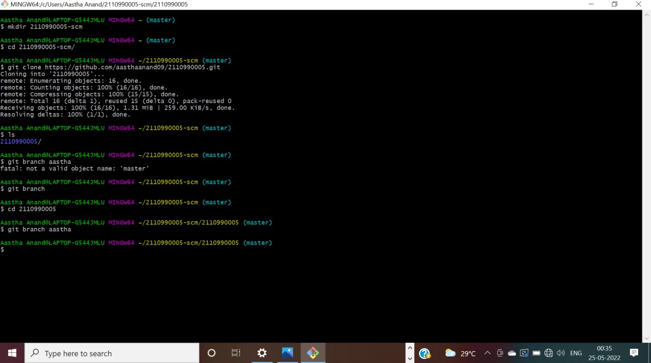

Push the modified branch using git push origin *branchname*.

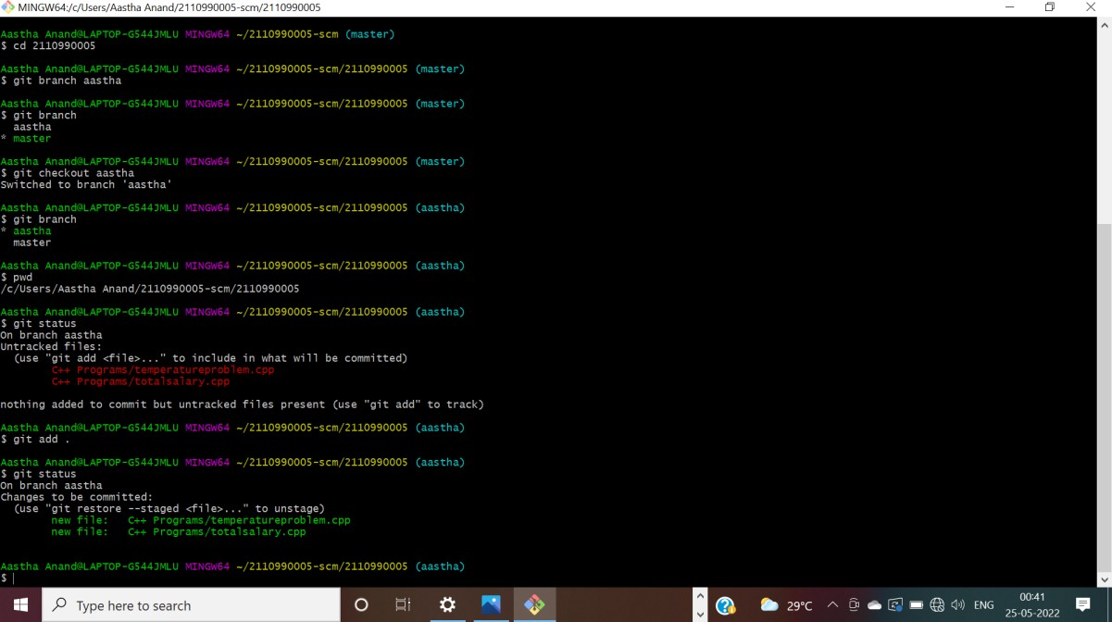

Open a pull request by following the procedure from the above experiment.

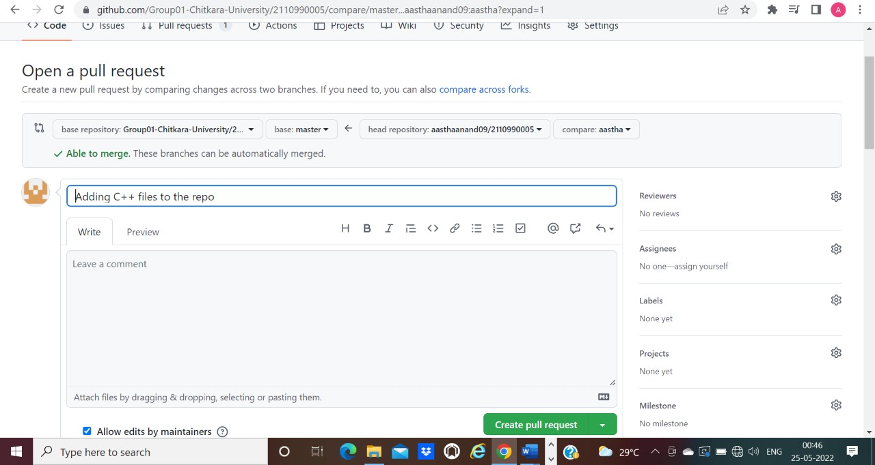

The pull request will be created and will be visible to all the team members. Ask your team member to login to his/her Git hub account. They will notice a new notification in the pull request menu.

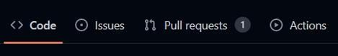

Click on it. The pull request generated by you will be visible to them.

Click on the pull request. Two options will be available, either to close the pull request or Merge the request with the main branch.

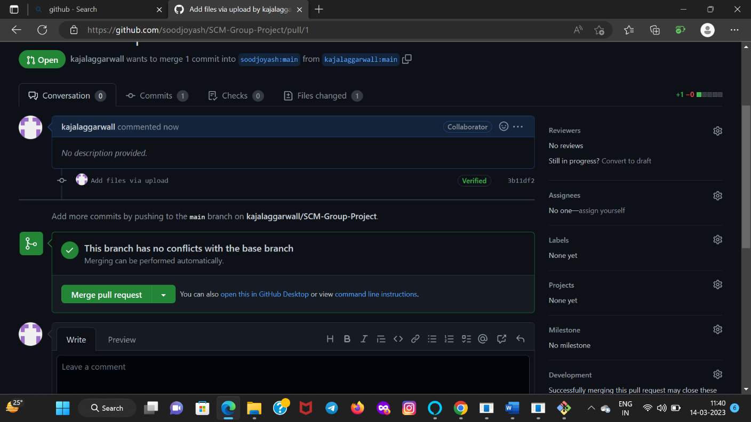

By selecting the merge branch option the main branch will get updated for all the team members.



By selecting close the pull request the pull request is not accepted and not merged with main branch.

The process is similar to closing and merging the pull request by you. It simply includes an external party to execute.

Thus, we conclude opening and closing of pull request. We also conclude merging of the pull request to the main branch.

# Experiment No. 4

Aim: Publish and print network graphs

The network graph is one of the useful features for developers on GitHub. It is used to display the branch history of the entire repository network, including branches of the root repository and branches of forks that contain commits unique to the network.

A repository's graphs give you information on traffic, projects that depend on the repository, contributors and commits to the repository, and a repository's forks and network. If you maintain a repository, you can use this data to get abetter understanding of who's using your repository and why they're using it.

Some repository graphs are available only

In public repositories with GitHub Free:

Pulse

Contributors

Traffic

Commits

Code frequency

Network

Steps to access network graphs of respective repository

On GitHub.com, navigate to the main page of the repository.

Under your repository name, click **Insights**.

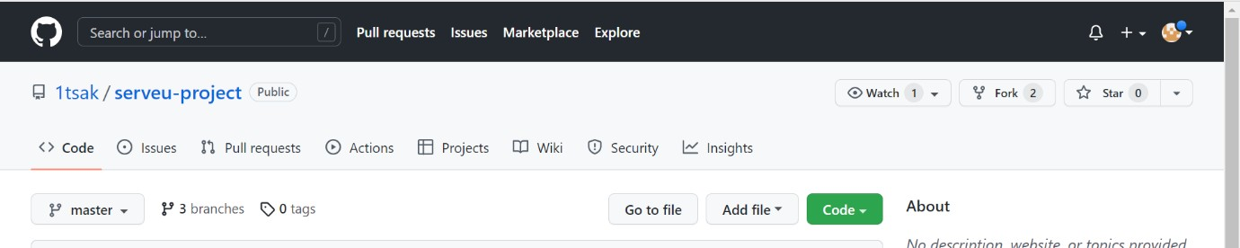

At the left sidebar, click on **Network**.

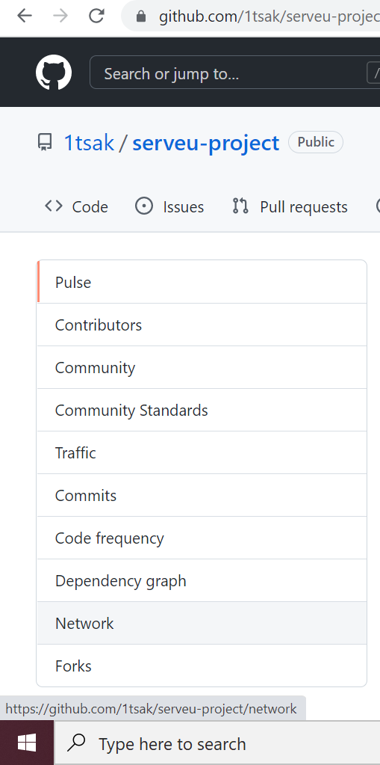

You will get the network graph of your repository which displays the branch history of the entire repository network, including branches of the root repository and branches of forks that contain commits unique to the network.

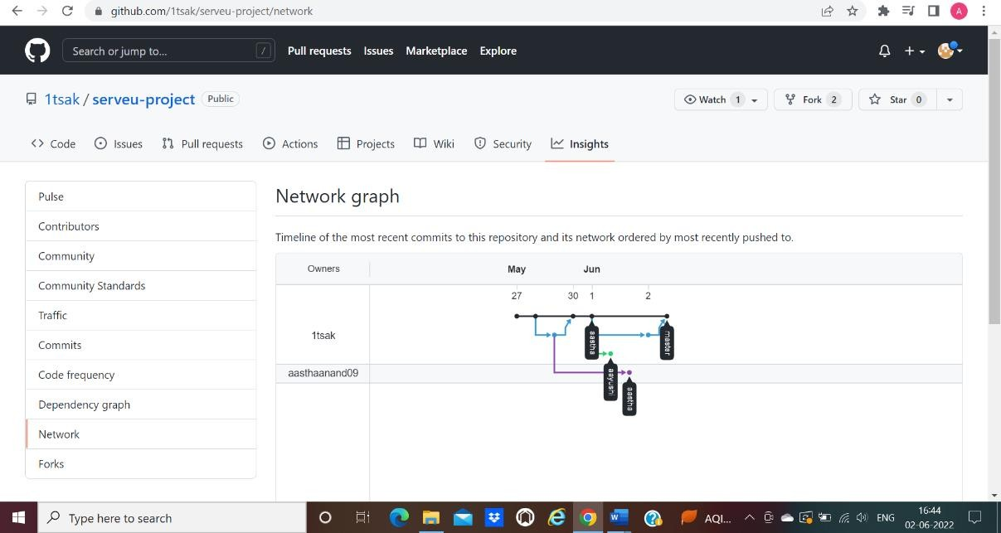

### Listing the forks of a repository

Forks are listed alphabetically by the username of the person who forked the repository

Clicking the number of forks shows you the full

network. From there you can click "members" to see who forked the repo.

On GitHub.com, navigate to the main page of the repository.

Under your repository name, click **Insights**.



In the left sidebar, click **Forks.**

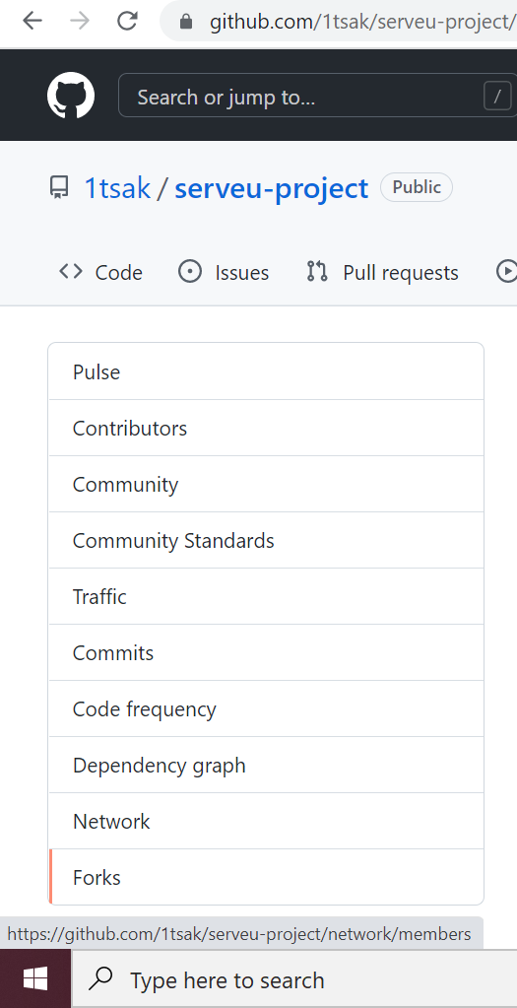

Here you can see all the forks

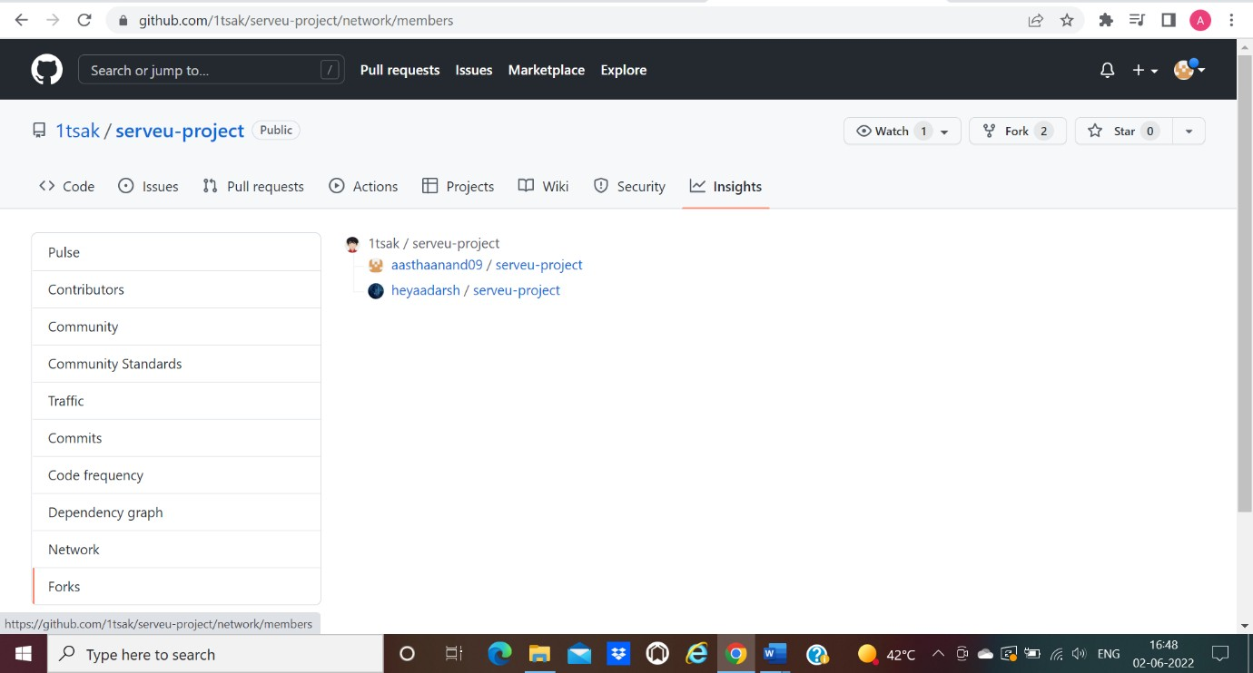

### viewing the dependencies of a repository

You can use the dependency graph to explore the code your repository depends on. Almost all software relies on code developed and maintained by other developers, often known as a supply chain. For example, utilities, libraries, and frameworks. These dependencies are an integral part of your code and any bugs or vulnerabilities in them may affect your code. It's important to review and maintain these dependencies.